BIOLOGY
Laboratory Manual
Xavier High School



Xavier High School • 30 West 16th Street • New York, NY 10011

Table of Contents

Lab Rules and Contract ………………………………………….. 4

Lab Report Guidelines …………………………………………… 8

Introduction to the Microscope ………………………………….. 11

Understanding Chemistry …………………………………………17

Biochemistry of Food ……………………………………………. 23

Observing Cork and Onion Cells ………………………………… 25

Comparing Plant and Animal Cells ………………………………. 29

Diffusion Through a Membrane ………………………………….. 32

Photosynthesis ……………………………………………………. 34

Cellular Respiration ………………………………………………. 38

Mitosis in Plant Cells ..……………………………………………. 39

Extracting DNA …………………………………………………… 42

Gel Electrophoresis ……………………………………………….. 44

Chromosome Simulation ………………………………………….. 45

Protein Synthesis ………………………………………………….. 49

Probability and Inheritance ……………………………………….. 54

Pedigree Analysis . ………………………………………………... 59

Genetics …………………………………………………………… 62

Evolution of Populations ………………………………………….. 65

Nitrogen Cycle Game ……………………………………………... 68

Predator-Prey Simulation …………………………………………. 74

Worm Dissection ………………………………………………….. 77

Frog Dissection ……………………………………………………. 82

Fetal Pig Dissection ……………………………………………….. 88

Works Cited ……………………………………………………….. 100

Safety in the Biology Laboratory

A. GENERAL
1. Work carefully and cautiously in the laboratory, using common sense and good judgment at all times.
2. EATING AND DRINKING ARE PROHIBITED in the laboratory.
3. Identify the location of all exits from the laboratory and from the building.
4. Be familiar with the location and proper use of fire extinguishers, fire blankets, first aid kits, spill response kits, and eye wash stations in each laboratory.
5. Report all injuries, spills, breakage of glass or other items, unsafe conditions, and accidents of any kind, no matter how minor, to the instructor immediately.
6. Perform only those lab activities assigned and explained by the instructor Listen carefully to instructions and follow them exactly.
7. Keep sinks free of paper or any debris that could interfere with drainage.
8. Lab tables must be clear of all items that are not necessary for the lab exercise.
9. Wash hands and the lab tables with the appropriate cleaning agents before and after every laboratory session.

B. OPEN FLAMES - FIRE HAZARD
1. Identify and be familiar with the use of fire extinguishers that are located in the hallways and laboratory rooms.
2. Flames are only to be used under the supervision of the instructor.

C. SHARP OBJECTS AND BROKEN GLASS
1. Pointed dissection probes, scalpels, razor blades, scissors, and microtome knives must be used with great care, and placed in a safe position when not in use.
2. Containers designated for the disposal of sharps (scalpel blades, razor blades, needles; dissection pins, etc.) and containers designated for broken glass are present in each laboratory. Never dispose of any sharp object in the regular trash containers.
3. Report all cuts, no matter how minor, to the instructor.
4. Do not touch broken glass with bare hands. Put on gloves and use a broom and dustpan to clean up glass. Dispose of ALL broken glass in the specific container marked for glass. Do not place broken glass in the regular trash.
5. Scalpels and other sharp instruments are only to be used to make cuts in the specimen, never as a probe or a pointer.
D. INSTRUMENTS AND EQUIPMENT
Care must be used when handling any equipment in the laboratory. Students are responsible for being familiar with and following correct safety practices for all instruments and equipment used in the laboratory.
Microscope Handling
1. Microscopes must be carried upright, with one hand supporting the arm of the microscope and the other hand supporting the base. Nothing else should be carried at the same time.
2. Microscope must be positioned safely on the table, NOT near the edge.
3. After plugging the microscope into the electrical outlet, the cord should be draped carefully up onto the table and never allowed to dangle dangerously to the floor.
4. The coarse adjustment must NEVER be used to focus a specimen when the 40x or oil immersion lens is in place.
5. When finished with the microscope, the cord should be carefully wrapped around the microscope before returning it to the cabinet.
6. The microscope must be placed upright in the cabinet.
7. All prepared microscope glass slides are to be returned to their appropriate slide trays; wet mount preparations are to be disposed of properly.
8. Malfunctioning microscopes should be reported to the instructor.
Hot Plates and Water Baths
1. The instructor will regulate the temperature of hot plates and water baths with a thermometer.
2. This equipment must be placed in a safe place.
3. Use insulated gloves or tongs to move beakers or test tubes in and out of the water baths.
4. Use care when working near hot plates and water baths, as they may still be hot even after being turned off.
E. PRESERVED SPECIMENS
1. Gloves (latex and nonlatex) are provided to handle preserved specimens.
4. Notify the instructor if there is a spill of preservative.
5. Body parts or scraps of the specimen are NOT to be disposed of in the sink.
6. Dispose of dissecting pins or other sharp objects in the red sharps containers, NOT in the regular trash.
8. Follow the directions of the instructor concerning the proper disposal of preserved specimens after they are finished being used.

Laboratory Safety Agreement

My name is ___________________________________________

My teacher’s name is ___________________________________

I have carefully read and understand the biology science laboratory safety procedures. I agree to adhere to these guidelines, and realize that it is my responsibility to do so, for my own safety and the safety of all others.

I understand that failure to comply with the rules laid out for appropriate laboratory behavior and procedure can result in disciplinary action with the Dean of Students Office and/or be reflected in my laboratory grade.

Signature: ________________________________

Date: ________

What to Include in a Lab Report

Title – may be creative, but must be descriptive

Introduction – background information telling the reader what the question is why it is worth doing all the work to find an answer
- Include the specific question(s) or hypothesis tested in the experiment
- Cite appropriate literature – reference for every idea that is not your own

Methods – explanation of exactly what was done
- Detailed enough that someone else could repeat the experiment
- Cite literature if methods were obtained from texts, reading, lab handouts, etc.

Results – summary of the data you got
- Include basic trends and relationships in the data (does not include raw data)
- Data should be summarized or quantitatively analyzed (statistics)
- Summarized in tables, graphs, text, or a combination
- Usually include limited interpretation related to or explaining the data results
Tables and Graphs:
- Should be numbered sequentially and referred to as “Figure 1” etc.
- Each must have a legend underneath or before it
  - Briefly explains what information is represents or contains
- Label your axes, rows or columns and include units

Discussion – analysis of the results in terms of how they can be interpreted and what the implications might be
- Ties the whole paper together including the broader context of the study
- May refer to results already presented in the results section but does not include any additional results
- May include reference to other literature
- Statements made should be supported by the data in results or other studies cited – speculation should be limited

References:
- Also referred to as “Literature Cited”
- Most citations show up in the introduction, methods, and discussion
- Web page internet references are typically not acceptable
- Citations should be complete enough that someone else can find the paper
- Journal articles include author(s), year published, title of paper, name of journal, journal volume, journal number or issues, and pages

Lab Report Rubric

Name Course/Class Date
Task/Assignment

Performance Criteria

Introduction to Report
1. The title states clearly both the independent and dependent variables and the results of the experiment.

2. The title of the report is written in a clear declarative statement.

3. A concise abstract (not more than 250 words) of the lab is provided.

Question/Problem
4. The question/problem that the lab was designed to answer is clearly stated.

5. Relevant literature and prior observations are cited.

6. The hypothesis is stated in the "If-and-then" format. It predicts the influence of the independent variable on the dependent variable.

Procedures for Experiment
7. The procedures for controlling and measuring the dependent variable are well defined and clear.

8. A detailed, logical, step-by-step set of procedures that were used for conducting the lab is listed.

 | Assessment
 | Expert | Proficient | Emergent | Novice
9. Safety concerns are listed among the procedures.

Performance Criteria  Data Organization and Display  10. Table is designed for the types and quantities of data collected. All relevant data are completely and accurately recorded in the table. All measurements are recorded with the proper magnitude, unit and have the correct number of sig figs.  11. Title of graph clearly relates to the data displayed. Intervals on the graph are scaled appropriately and spaced evenly. All parts of the graph are accurately labeled. The set of data is plotted on the graph completely and accurately.  Data Analysis  12. Existing patterns can be discerned within the data, based on the given interpretation. All calculations are accurate. Appropriate graphics are used effectively to display and analyze the data.  Conclusions  13. A response to both the question and hypothesis is clearly and completely provided and is consistent with the data.  14. Interpretations, as well as limitations, of the data are included.  15. Unresolved questions and problems are listed.  16. Questions for further study are developed.  Language Usage  17. Language is used correctly and purposefully.  18. All words are spelled correctly.  19. The report is neat, legible, and presentable. | Assessment
 | Expert | Proficient | Emergent |  | Novice
 | Final Grade:
Comments

Introduction to Using a Microscope

“Micro” means TINY and "scope" means TO VIEW. Microscopes are tools used to enlarge images of small objects so as they can be studied. The compound light microscope is an instrument containing two lenses, which magnifies, and a variety of knobs to resolve (focus) the picture. Because it uses more than one lens, it is sometimes called the compound microscope in addition to being referred to as being a light microscope. In this lab, we will learn about the proper use and handling of the microscope.

Objectives:
- To learn the parts of a microscope
- To learn to prepare and observe a wet mount
- To be able to explain the proper procedure for focusing under low and high power using the compound light microscope.

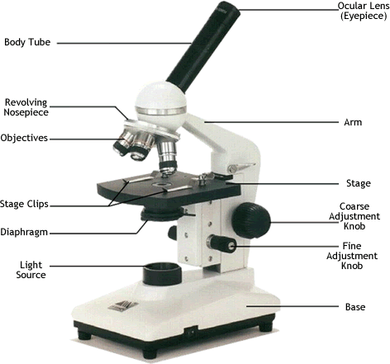

Materials:

Microscope
Slides
Cover slips
Lens paper
Newspaper
Water
Pipette
Scissors

Procedure:

PART I:

1. Compare your microscope with the Figure above. See if you can identify each part on your microscope.

2. Note whether your microscope uses a mirror to reflect light or an illuminator (light bulb) to produce light.

3. Examine the diaphragm. Adjust it to the largest opening so that the most light enters.

4. While looking at your microscope, slowly turn the coarse adjustment towards you.

What changes on the microscope?

5. Turn the course adjustment until the low power objective is about 3 cm from the stage..
Look at the number followed by an “X” on the side of each objective. This number is the objective’s magnifying power. The “X” stands for “times.” The number written on the objective tells you how many times an object is magnified by this lens.
The low power can often be the shortest objective, but many times there is a shorter objective that is used to scan a slide simply to find the specimen. This objective is called the “scanning objective” and usually magnifies about 4X

What is the magnifying power of the low-power objective?

What is the magnifying power of the high-power objective?

6. The ocular lens also has a magnifying power. The total magnifying power of the microscope is easy to calculate. Multiple the magnifying power of the ocular by the magnifying power of the objective. For example, if the ocular is 5X and the objective is 10X, the total magnification of the object being views is 5X x 10X = 50X

What is the magnifying power of the ocular lens?

What is the total magnification produced when the low-power objective is used?
Show your calculations.

What is the total magnification produced when the high-power objective is used?
Show your calculations.

PART II:

1. Cut out a small letter “e” from a newspaper and place it on a clean slide face up.

2. Using a pipette, add one drop of water to the slide.

3. Place the cover slip on top of the “e” at a 45-degree angle and lower.
Do not press on the cover slip, I should rest on the top of the water.
A good wet mount is free of bubbles. If you mount has too many bubbles, take off the cover slip, absorb the water with paper towel, and try again.

4. Once you’ve placed the slide on the microscope, and fastened it with the stage clips, use the scanning objective to locate your “e” and place it in the center of the field of view (you may have to turn the adjustment knob to help you focus). It is helpful, if you can, to keep both eyes open while you look through the ocular lens, this will prevent you from straining your eyes.

5. Adjust the nosepiece so that you are now looking through the low-power objective. Slowly turn the course adjustment until the letter comes into focus. Use the fine adjustment to sharpen the focus.

Draw what you see on the slide in figure below.


6. Move the slide to the left. Which way does the image move?

7. Move the slide to the right. Which way does the image move?

8. When you move the slide backwards and forwards, what happens to the image?

9. Observe the “e” as you change the diaphragm to each of its settings.
What does the diaphragm control?

10. CAREFULLY, watching from the side, switch to the high-power objective. Make sure that the objective does not hit the slide, but expect that it will be very close.
Using ONLY the fine adjustment, refocus on the letter “e”
Draw what you see on the slide in figure below.

Is the field of view larger under high power or low power?

Compare the brightness of the filed under high power and low power.

PART III

1. Make a wet mount using a 1cm square of colored newspaper. Try to choose a square that has both light and dark tones, but not black.
Before looking at the paper under the microscope, record the color(s) you see here:

2. Resolving power is the ability to distinguish between two separate points that are very close together. Microscopes have a resolving power greater than that of the human eye.
Observe the slide under lower power. Then switch to high power.

How is the color distributed? Is there a pattern? Does it seem random?

What colors do you see now?

3. Prepare another wet mount, this time using two hairs (try to find hair of two different color). Cross them on the slide, then add a drop of water and the cover slip.
View the slide under lower power. Focus on the point where the hairs cross.

Are both hairs in focus?

Switch to high power. Are both hairs in focus?

Analysis:

Briefly describe the function of each of the microscope parts listed below

Part | Function
Ocular lens
Coarse adjustment
Nosepiece
Objectives
Stage
Stage clips
Diaphragm
Illuminator
Fine adjustment

1. Why should a wet mount have no bubbles?

2. What did the microscope do to the image of the letter “e”?

3. Why must you center and focus the object in the field of view under low power before switching to high power?

4. Why is only the fine adjustment used for high power?

5. How could you use the fine adjustment to tell which hair was above the other?

Chemistry of Life
Ball and Stick Chemistry Set

New Vocabulary:

Atom ____________________________________________________________

Molecule _________________________________________________________

Substance _________________________________________________________

Background:
How many substances have you come into contact with in your lives (wood, steel, plastic, nylon, Teflon, leaf, skin, fingernail, beak, claw, hair, cotton, paper, wool, rayon, cardboard, glue, paste, flour, sugar, salt, pepper)? Dozens? Hundreds? Thousands? Millions?
All substances are made of just 116 different kinds of atoms. These different types of atoms are referred to as elements. An element is a substance that is made entirely from one type of atom. How can there possibly be so many different kinds of substances when there are so few kinds of atoms?
Atoms are composed of particles called protons, electrons, and neutrons Protons carry a positive electrical charge, electrons carry a negative electrical charge and neutrons carry no electrical charge at all. The protons and neutrons cluster together in the central part of the atom, called the nucleus and the electrons 'orbit' the nucleus. A particular atom will have the same number of protons and electrons and most atoms have at least as many neutrons as protons.
Atoms are basic building blocks that can combine with one another in an enormous variety of patterns. They link together in regular ways to form molecules
A molecule, by definition, contains more than one atom (e.g. H₂ - hydrogen gas, N₂ - nitrogen gas, O₂ - oxygen gas, H₂O - water, CO₂.- carbon dioxide gas).
Molecules may contain one or more kinds of atoms and may be solids, liquids, or gases at room temperature. Billions of the same kind of molecules together form a homogeneous substance such as water or absolute alcohol. A homogeneous substance is one that contains the same molecules or atoms throughout.
Living cells are so small that we typically view them with powerful magnifying devices such as light and electron microscopes. Yet a single living cell contains billions of atoms and molecules.

Some molecules consists of two or more atoms held together by covalent chemical bonds. Covalent bonds are formed when two atoms share a pair of electrons between them. They are strong bonds that serve to hold atoms tightly together in molecules.
One covalent bond is formed by one pair of shared electrons, one electron from one atom and the other electron from the other atom. In water, for example, there are two single covalent bonds.

Figure 1. Water

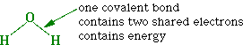

A pair of atoms may form more than one covalent bond between them, as in O₂ or O=O.

Figure 2. Oxygen

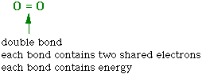

The number of covalent bonds formed by a particular small atom is usually equal to the number of electrons it needs to fill its outer orbital. Thus hydrogen forms one bond, oxygen forms two bonds, and carbon forms four bonds.

How many covalent bonds are in each of the following molecules?

Oxygen gas O₂ __________________

Water H₂O _____________________

Carbon dioxide CO₂ ______________

Draw the molecules to show the covalent bonds between the atoms.

OXYGEN WATER CARBON DIOXIDE

Do you know: Where is the biologically usable energy stored in a molecule?
Activity:

The modeling kit:
The round wood pieces with holes in them represent various types of atoms. Each color represents a different element. The wood links and springs represent covalent bonds.

Examine one of the hydrogen atoms.

How many holes (bonding points) does it have? __________

How many holes (bonding points) are in the black carbon atoms? __________

How many holes (bonding points) are in the red oxygen atoms? ___________

A carbon atom is very versatile and can bond to another carbon atom with a single, double, or triple bond. To see how, take out 6 black carbon atoms and connect them in pairs as follows:

1. Connect one pair of carbon atoms together with one covalent bond

Model 1: Carbon - carbon single bond
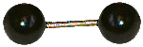

2. Connect the second pair together with two covalent bonds

Model 2: Carbon - carbon double bond
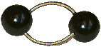

3. Connect the third pair together with three covalent bonds

Model 3: Carbon - carbon triple bond
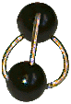

Questions:

For each bonded pair, try rotating the atoms around their bonds and also wiggling the atoms with respect to each other. What happens?

Which arrangement, 1, 2, or 3 shared covalent bonds, places the least constraint on the free motion of atoms? Explain

Which arrangement, 1, 2, or 3 shared covalent bonds, places the greatest constraint on the free motion of atoms?

The greater the constraints on free motion, the less stable the bond and the more likely it will break. Which of these situations, 1) a single bond, 2) a double bond), or 3) a triple bond produces the most constrained, least stable, most reactive molecule?

3. Make a model of hydrogen gas, H₂.
It consists of two hydrogen atoms connected by a single covalent bond.
Take two hydrogen atoms and connect them together with a short link.

Model 4: Hydrogen gas
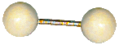

Questions:
What does the link between the two atoms represent?

Could you connect more than two hydrogen atoms together?

Explain, in terms of the structure of the atoms and their shared parts, why or why not.

4. Another simple molecule is oxygen gas, O₂.

To model oxygen, take two oxygen atoms and covalently bond them together in such a manner that nothing else could be attached to either atom.

Model 5: Oxygen gas

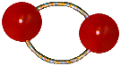

Questions:

How many covalent bonds are required to connect two oxygen atoms together?

What is this number of covalent bonds between two atoms called?

5. Molecules of both hydrogen and oxygen gas have two atoms.
Their formulas are H₂ and O₂. The H stands for hydrogen; the O for oxygen. The subscript number in each formula tells how many of each particular type of atom are in the molecule, 2 hydrogens in hydrogen gas and 2 oxygens in oxygen gas.

The molecular formula for water is H₂O. What atoms make up water and how many of each are there?

Construct a model of water. Obtain one oxygen atom and two hydrogen atoms and connect them together.

Draw what it looks like in the space below. Note that the bonding angle is larger than 90º

In water, electrons are not shared equally between the atoms because oxygen is highly electronegative. Electronegativity is a measure of the ability of an atom in a molecule to attract electrons to itself. Because oxygen is highly electronegative, the shared electrons in covalent bonds are much more attracted to the oxygen atom than to the hydrogen. Because of this, the oxygen takes on a partial negative charge while the hydrogens take on partial positive charge. This polarity makes water molecules behave like little magnets and accounts for many of the unusual properties of water.

Figure 3. Water molecule
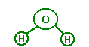

Partial charges make water molecules behave like little magnets, with the (negative) oxygen of one water molecule attracting the (positive) hydrogen of another water molecule. The attraction between atoms in different molecules due to partial charges in this case is called a hydrogen bond. Hydrogen Bonds are very weak bonds because the atoms are attracted to each other by only partial, not full, charges. Hydrogen bonds are much weaker than covalent bonds - they are readily broken and readily formed anew because no electrons are actually shared.

Conclusion Questions: (do theses questions on loose-leaf paper)

1. Describe the structure of an atom.

2. Describe how covalent bonds are formed.

3. Electrons are shared equally in a covalent bond joining two atoms of the same element. Name three molecules in which this is the case.

4. If a homogeneous substance is one that contains the same molecules or atoms throughout, what do you think a heterogenous substance is?

5. What is electronegativity? What is hydrogen bonding? How does electronegativity allow for Hydrogen bonding?

6. What is polarity?

Chemical Detectives

In this lab experiment you are going to play the role of a chemical detective to decide which chemicals are present in common food substances. Due to the fact that certain reagents act as chemical indicators of the presence of specific chemicals. The knowledge of how these reagents react will allow us to test for these chemicals in foods familiar to us.

Materials:

Food:
apple, egg, potato chips, popcorn
potato, orange, cheese, cooked rice

Reagents:
Iodine, Biuret solution
Indolphenol, Benedict’s solution

Procedure: Combine each of the chemical unknowns with the proper reagents to determine the presence of the chemistry within the food.

CONTROLS

Food | Reagent | Reaction
Starch | Lugol’s Iodine
Protein | Biuret solution
Vitamin C | Indolphenol
Glucose | Benedict’s solution  +  heat

Hypotheses:

The following foods will contain starch _______________________________________

The following foods will contain protein ______________________________________

The following foods will contain vitamin C ____________________________________

The following foods will contain glucose ______________________________________

Experiment Results:

Food | Lugol’s | Biuret | Indolphenol | Benedict’s +  Heat | Chemicals  Present
Apple

Egg White

Potato Chip

Popcorn

Potato

Orange

Cheese

Cooked Rice

Observing Cork and Onion Cells

One of the first scientists to look at cells under a microscope was an English scientist by the name of Robert Hooke. He viewed and described the appearance of cork under the microscope and decided to name the tiny box-like structures that he observed “cells” because they looked like the small chambers where monks lived.
By the early part of the 19th century, it was accepted that all living things are composed of cells. Cells come in a variety of shapes and sizes, and cells perform different functions. Although cells may appear outwardly different, they resemble each other because they share common structures.

Materials:

Microscope
Slides
Cover slips
Razor blade
Pipette
Water
Cork stopper
Onion
Forceps
Lugol’s iodine solution

Procedure:

PART I: Cork Cell

1. Place the cork on paper towel. Holding it firmly, shave a thin section from the cork with a razor blade or scalpel. The slice must be paper thin.

2. When you have a piece thin enough for light to pass through, prepare a wet mount.
Place the cork slice on a clean slide and add a small drop of water.

3. Cover the specimen with a cover slip. The cover slip should lie flat.

4. Examine the cork under low power. The best place to look is along the thin edge of the slice you prepared.
Draw what you see below.

5. Examine the cork under high power. Draw what you see below.

How do the cells look different under lower power than under high power?

What structures, if any, can you identify in the cell?

PART II: Onion Cell

1. Set up your microscope.

2. Take a piece of onion from the front of the room, and fold it so that it doesn’t completely break. Peel back one half of the onion so that you are able to obtain one layer of epidermal tissue (your teacher will demonstrate this in class).

3. Place a small drop of water on a clean slide before you add the layer of onion tissue.

4. Place a coverslip on the slide, slowly lowering it over the sample to avoid creating air bubbles.

Every plant cell is surrounded by a nonliving cell wall composed chiefly of cellulose. Pressed tightly against the cell wall is the cell membrane which surround the cytoplasm. The central part of the cell consists of the large, fluid-filled vacuoles. The spherical nucleus appears as a dense body in the cytoplasm near the cell wall.

Make a diagram of a single cell. Label any and all parts you can identify

Staining the cells will enable you to cell the structures in more detail.

6. Your instructor will demonstrate an efficient way of adding iodine to your prepared onion slide, instead of preparing a new one.
Add a small drop of iodine to one side of the cover slip. Take a strip of paper towel and touch it to eh water at the opposite edge. This should pull the stain under the cover slip. If more stain is needed, repeat the process.

7. Place the slide on the stage and view the slide under the scanning objective. Once you have found an area with several good cells, switch to a higher objective. Remember to only use the fine adjustment to focus at higher powers.

8. Draw one or two onion cells in detail. Label any of the following that you can see through your microscope: cell membrane, cytoplasm, cell wall, vacuole, nuclear membrane, nucleus.

Analysis:

1. How can you tell that cork cells are not living?

2. What structures did you see in onion cells that you did not see in cork cells? What structures did you see in both?

3. What is the advantage of using stain?

4. How can you tell that an onion cell has depth?

Comparing Plant and Animal Cells

Plant and animal cells have many structures in common as well as some basic differences. Plant cells have a rigid cell wall and if they are green they have chloroplasts. Animal cells lack both a cell wall and chloroplasts. They also lack a central vacuole that exists in plant cells.
In this lab you will observe and compare animal cells and plant cells. You will first examine epithelial cells from the inside of your cheek. Epithelium is a type of tissue that covers the surface of organs and cavities of the body, as well as your skin.
You will also look at cells from a leaf of the plant Elodea. The cells of this plant are green because they contain the pigment, chlorophyll. This is a pigment found in chloroplasts and allows a plant to absorb sunlight and manufacture its own food.

Materials:

Microscope
Slides
Cover slips
Toothpick
Pipette
Elodea
Forceps
Lugol’s iodine solution
Methylene blue stain

Procedure:

PART I: Human Cheek Cell

1. Obtain epithelial cells by gently scraping the inside of your cheek (in your mouth) with a clean toothpick. It may not look like there is anything on the tip of the toothpick when you are through, but there are microscopic skin cells.

2. Stir the material from the toothpick in a drop of water on a clean slide.
Through the toothpick away when you are through.

3. Add a small drop of methylene blue stain to the slide.

4. Carefully place a cover slip on the slide.

5. Examine the slide under low power. When you find some cells that are separate from each other, examine them under high power.

Neatly draw a few cheek cells. Label any of the following that you can see through your microscope: cell membrane, nucleus, nuclear membrane, cytoplasm

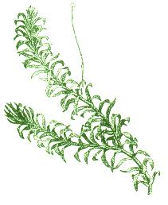
Part II: Elodea Leaf Cell

1. Break off a small leaf near the tip of an elodea plant.

2. With forceps, place the entire leaf in a drop of water on a clean slide
Add a cover slip

3. Examine the leaf under low power.
The boundary you see around each cell is the cell wall
The numerous small, green bodies in the cells are the chloroplasts

4. Look for an area in the leaf where you can see the cells most clearly.
Examine these cells under high power.
Describe the shape and location of the chloroplasts

Make a drawing of an elodea cell. Label any structures you see:

5. To see the chloroplasts move, warm up the slide under a bright lamp for a few minutes.
Describe how the chloroplasts move in a cell

Break off another elodea leaf and place it in a drop of Lugol’s iodine solution on a clean slide. Add a cover slip.
Make a drawing of a stained cell. Label the cell wall, cell membrane, chloroplastas, nucleus, nucleolus, and the large vacuole

Analysis:

1. What structures do human epithelial cells have in common with elodea cells?

2. How do human epithelial cells and elodea cells differ?

3. Which cells seem to be arranged in a more regular pattern?

4. How do the shape of the epithelial cells differ from that of the cheek cells?

5. Both plant cells and animal cells contain mitochondrion and yet there were not visible in the cells you viewed in this lab. Does this mean that these organelles are not found in cheek and onion cells? Why or why not? Explain your reasoning.

6. Why do you think we use stain on the cells?

Diffusion through a Membrane

Objectives:
- Learn the simple test for starch and sugar
- Observe the results of diffusion through a cellophane membrane
- Determine the permeability of a nonliving membrane for glucose, iodine, and starch

Materials:

Cellophane dialysis tubing
Starch solution
Saturate glucose solution
Lugol’s iodine solution
25 ml graduated cylinder
300 ml beakers
test tube
pipette

Procedure:

PART I:

1. Soak a 15cm length of cellophane dialysis tubing in water until it is soft and pliable
Part the ends of the tube to allow liquid to be poured within the walls of the tubing
Tie one end of the tubing in a firm knot

2. Fill the tube about half full with starch solution

3. Add 10ml of the glucose solution

4. Tie the other end of the tube closed with a firm knot
Rinse the outside of the tube with water

5. Mix 15ml of iodine solution into a 300ml beaker that is half filled with tap water

6. Place the cellophane dialysis tube in the beaker. Set this aside for 20 minutes

After 20 minutes, record your results below:
What color changes did you observe in the cellophane tubing and in the beaker?

__________________________________________________________________

__________________________________________________________________

7. With a pipette, take several drops of solution from the bottom of the beaker. Place this in a clean test tube. Add a few drops Benedict’s solution and place it in a beaker of boiling/hot water for 3 minutes

Record any color change _____________________________________________

PART II:

1. Add one pipette full of glucose solution to a test tube.

2. Rinse the pipette

3. Add a few drops of iodine solution to the test tube and stir

4. Record any color change in Table 1 (if there is no reaction – write “NR”)

5. Repeat steps 1-4 testing Logol’s iodine solution with starch and with tap water

6. Repeat steps 1-4 testing Benedict’s solution with glucose, starch, and tap water

Table 1
 | Glucose | Starch | Tap water
Lugol’s Iodine solution
Benedict’s Solution

Analysis:

1. What to Lugol’s iodine solution and Benedict’s solution test for?

2. What caused the color change you observed in step 6 in Part I?

3. Was there evidence of starch in the solution in the beaker? How could you tell?

4. Given the results in step 7 in Part I, what substance was present in the solution in the beaker?

5. Which substances diffused through the cellophane tubing? In which direction?

Photosynthesis Lab

Plants undergo photosynthesis to convert sunlight energy to usable chemical energy in the glucose molecule. This process requires the reactants carbon dioxide and water. It yields in the presence of sunlight, enzymes and chlorophyll, the products glucose and oxygen. The amount of oxygen gas given off by a plant during photosynthesis can be used to determine how rapidly or slowly the process is occurring.

PART I

In this experiment you will measure the effect of light intensity on the rate of photosynthesis. You will expose Elodea samples to various light intensities, and determine the relative rates of photosynthesis by observing changes in pH.

Materials:

pH paper
6 50mL test tubes
3 15cm-long sprigs of Elodea
250mL graduated cylinder
Sodium bicarbonate (baking soda)
Light source
Distilled water
Electronic Balance
3 beakers

Procedure:

1. Mark the six test tubes – A – Experiment & A - Control
B – Experiment & B - Control
C – Experiment & C - Control

2. Using a graduated cylinder, poor 200 mL of distilled water into a beaker.

2.Weigh out 2g sodium bicarbonate sample on weighing papers.
If you are using a mechanical balance, first find the mass of the weighing paper (or zero the balance while the paper is being weighed) then add the bicarbonate

3. Add a sodium bicarbonate sample to the beaker and stir the solutions until the chemical is dissolved.
When you add sodium bicarbonate to water, carbon dioxide (CO₂) will form.

How could you use the concentration of CO₂ to measure the rate of photosynthesis?

4. Test the pH of the solution and record in the DATA TABLE as pH before experiment.

What can you infer about the relationship between the pH of a solution and its CO₂ content?

5. Obtain three 15-cm-long sprigs of freshly cut Elodea. Place one sprig of Elodea in each experiment labeled test tube.

6. Place test tubes A in darkness, test tubes B in room light, and test tubes C in front of a light bulb.

7. After 10, 20 and then 30 minutes, use pH paper to test the pH of the solution in each test tube. Record your results in the DATA TABLE as pH after experiment.

DATA

 | pH Start |  | 10 Min |  | 20 Min |  | 30 Min
 | Exp | Control | Exp | Control | Exp | Control | Exp | Control
Sample A Darkness
Sample B
Room light
Sample C
Bright Light

Analysis:

How did the pH of the solution in each of the test tubes change after the Elodea was added and the 20 minute time elapsed?

What is the relationship between change in pH and rate of photosynthesis?

What purpose did solution D serve in this experiment? Did its pH change after Elodea was added?

According to your experiment, how is photosynthesis affected by light intensity?

PART II

Green plants use sunlight to make glucose. To do so, the plant must use carbon dioxide and water in a process called photosynthesis. The glucose made by plants is used by plants and animals as a source of energy. To release the energy contained in the bonds of glucose, the glucose must be converted to ATP. The process by which ATP is made from glucose is called cellular respiration. Respiration also produces waste products including carbon dioxide and water, which are the same substances that served as raw materials for photosynthesis. In water, carbon dioxide dissolves to form a weak acid. As a result, an acid-base indicator such as bromothymol blue can be used to indicate the presence of carbon dioxide. In this laboratory investigation, you will use bromthymol blue to explore the relationship between photosynthesis and respiration.

Materials:
2 20ml test tubes
Bromthymol blue solution
rubber stoppers
300ml beaker
Elodea
light source
drinking straw

Procedure:
1. Using the beaker, measure out 100ml of distilled water. Add ten drops of Bromothylol Blue to the distilled water.

2. Insert one end of a drinking straw into the bromthymol blue solution in beaker.

3. Gently blow throught the straw. Keep blowing until there is a change in the appearance of the bromthymol blue solution.

4. Pour the new solution into the test tubes

5. Place a sprig of Elodea into each test tube. Stopper the test tubes.

6. Place one flask in the dark. Place the other test tube over the light source

7. After 40 Mins, examine each test tube. Note any change in the appearance of the bromthymol blue solution.

Record your observations in the data table.

DATA

COLOR OBSERVATION | Test Tube 1 (light) | Test tube 2 (dark)
Before blowing into the flask
After blowing into the flask
After 10 Mins
After 20 Mins
After 30 Mins
After 40 Mins

Analysis:
1. What was the color of the bromthymol blue solution before you exhaled into it? After you blew into it? Why did it change color?

2. Why did we use bromthymol blue in this experiment?

3. Why was Elodea place in both test tubes?

4. What differences did you observe between the Elodea in the light and the Elodea in the dark? Why did this occur?

5. What is photosynthesis and how do our results demonstrate the requirements necessary for this process to occur?

http://oldmanhonda.com/Biology/WebLabs/Elodea/Elodea.html

Cellular Respiration

Cellular respiration is the general term which describes all metabolic reactions involved in the formation of usable energy from the breakdown of nutrients. In living organisms, the "universal" source of energy is adenosine triphosphate (ATP). The first step of cellular respiration is Glycolysis, the breakdown of glucose (a six-carbon sugar) to form two molecules of pyruvate. Glycolysis takes place in the cytoplasm of the cell. The resulting pyruvate may pass through one of several pathways, depending on the organism in question. In some organisms, such as yeast, fermentation occurs. In other organisms, when oxygen is present, aerobic respiration occurs. In this lab you will investigate the breakdown of various sweeteners and measure the release of carbon dioxide as evidence for respiration of yeast cells.

Materials:

250 mL beaker
lukewarm water
3 party balloons
1 piece of string
1 ruler
magnesium sulfate
3 packets sugar
3 ziplock bags of yeast
3 empty water bottles

Procedure:

1. In 2 of the water bottles mix 200 mL of warm water with
a. glucose
b. magnesium sulfate and sugar
c. nothing

2. Add a bag of yeast to each of the 3 water bottles and gently swirl.

3. Cap each bottle with a balloon.

4. Use a piece of string and the ruler to measure each balloon's circumference every 5 minutes

5. Create a data table and record all data.

6. Plot the results on a graph.

Analysis:

What was the purpose of the water bottle with just water and yeast?

What evidence, if any, was there for cellular respiration taking place?

Is yeast living?
Mitosis
Plant Cells

Cell division is the formation of two new cells from a single parent cell. It is a continuous process that includes two major events: mitosis and cytokinesis. Mitosis is the process that produces two identical nuclei from a single parent nuclei. Cytokinesis is the process that divided the cytoplasm of the parent cell between the two new cells.

Materials:

Microscope
Prepared slide (Onion root tip) – Longitudinal section

Procedure:

1. Place the prepared slide on the microscope stage and focus on a section at low power. Move the slide until you can see the root cap clearly. Arrange the slide so that the root cap is pointing toward you.
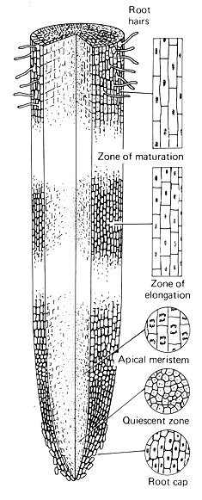

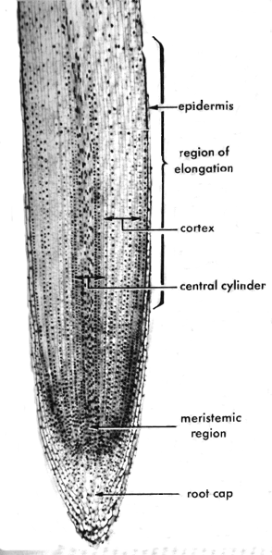

Just above the root cap is the meristem tissue. In this region, many of the cells are much smaller than those of the root cap. They are the new cells. They will grow before reproducing. Many of the larger cells o the meristem were in the process of mitosis before this root would have been removed to create the slide you are looking at. Chromosomes are visible in these cells because they have been stained.

Mitosis consists of 4 phases: Prophase, Metaphase, Anaphase, and Telophase.
Mitosis is part of a larger process called the cell cycle. When a living organism needs new cells to repair damage, grow, or just maintain its condition, cells undergo the cell cycle. In this lab you are going to determine the approximate time it takes for a cell to pass through each of the four stages of mitosis.

Use the images below to help you identify the stages of mitosis on the microscope slide.

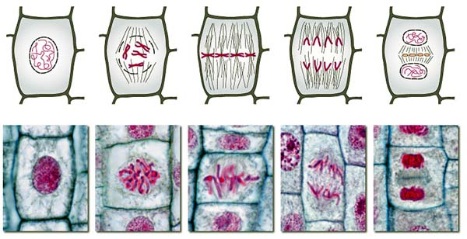

Interphase Prophase Metaphase Anaphase Telophase

2. Count the number of cells found in each stage of mitosis.

3. Determine the percentage of time each cell will spend in each stage of mitosis. Divide the number of each cell by the total number of cells and multiply by 100 to determine the percentage.

4. Place your values in the chart below:

Stage of Mitosis | Number of Cells | Percent of time  in each stage
Interphase |  | ____________ %
Prophase |  | ____________ %
Metaphase |  | ____________ %
Anaphase |  | ____________ %
Telophase |  | ____________ %
Total number of cells |  | 100 %

Analysis:

1. From your experiment, order the stages of mitosis according to their majority?

2. What happens to the nuclear membrane during prophase?

3. Why do the processes of mitosis occur?

4. Why are onion root tips used to study mitosis?

5. In what other areas of a plant would you expect to see many cells undergoing the process of mitosis?

DNA Extraction

DNA is the largest known molecule. A single unbroken strand can contain millions of atoms. When DNA is released from a cell it typically breaks up into tiny strand fragments. These tiny fragments have a slightly negative electric charge. Salt ions, common in many solutions, are attracted to the negative charges on the DNA fragments and prevent them from adhering to one another. By controlling the salt concentration of the solution containing the DNA fragments, DNA can remain fragmented or become very “sticky” and form large globs of molecular material.

Materials:

Blender
Stirring rod
Green peas
Salt
Detergent
Meat tenderizer
Contact lens solution
Pineapple juice
Rubbing Alcohol

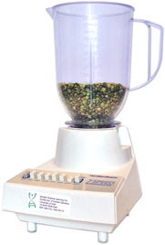

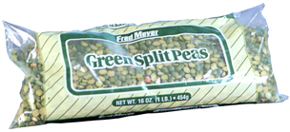

Procedure:

This part will be done by your teacher
Put in a blender:
- 1/2 cup of split peas (100ml)
- 1/8 teaspoon table salt (less than 1ml)
- 1 cup cold water (200ml)
Blend on high for 15 seconds.
The blender separates the pea cells from each other, so you now have a really thin pea-cell soup.
1. Pour your thin pea-cell soup through a strainer into another container
2. Add 2 tablespoons liquid detergent (about 30ml) and swirl to mix.
Let the mixture sit for 5-10 minutes.
3. Pour the mixture into test tubes or other small glass containers, each about 1/3 full.

4. Add a pinch of enzymes to each test tube and stir gently. Be careful! If you stir too hard, you'll break up the DNA, making it harder to see.
Use meat tenderizer, pineapple juice or contact lens cleaning solution for enzymes.

5. Tilt your test tube and slowly pour rubbing alcohol (70-95% isopropyl or ethyl alcohol) into the tube down the side so that it forms a layer on top of the pea mixture. Pour until you have about the same amount of alcohol in the tube as pea mixture.
6. DNA will rise into the alcohol layer from the pea layer. You can use a wooden stick or other hook to draw the DNA into the alcohol.
Alcohol is less dense than water, so it floats on top.
7. DNA is a long, stringy molecule that likes to clump together. You can use a stirring rod to gently obtain some of your DNA sample.

8. With a small sample. Make a wet mount and examine the material under a microscope.

9. Draw what you see below. Is it DNA?

Gel Electrophoresis

Agarose gel electrophoresis can resolve molecules based on charge, size, and shape. The technique of electrophoresis is based on the fact that DNA is negatively charged at neutral pH due to its phosphate backbone. For this reason, when an electrical potential is placed on the DNA it will move toward the positive pole:

Materials:

Various dyed DNA samples
Electrophoresis units and power supplies
0.8% agarose
buffer solution
Hot water bath to keep the agarose melted

Procedure:

Part I: Preparing the agarose gel

1. Set up casting dams and place a comb in the middle slot.

2. Pour agarose into gel deck. Pour until the gel comes close to the top of the gel deck, but do not overfill.

3. Wait for the agarose gel to solidify. Remove casting dams and comb.

Part II: Loading the samples

1. Record on data sheet where you will load the dye samples.

2. Load the numbered dye samples in the wells in the middle of the gel.

3. Connect electrophoresis unit to power supply (red to red, black to black). Plug in the power supply.

4. Turn on the power supply, and set voltage to 100 V. The dyes will start resolving toward both the negative and positive poles

5. Electrophorese samples for approximately 10 minutes. Turn off power supply, disconnect power cords from the chamber, and remove top of electrophoresis chamber.

http://gslc.genetics.utah.edu/units/biotech/gel/
Chromosome Simulation
Carolina Chromosome Modeling Kit

Materials
- 60 pop beads of one color
- 4 centrioles
- 60 pop beads of another color
- 8 magnetic centromeres

Background:

Meiosis takes place in all organisms that reproduce sexually. In animals, meiosis occurs in special cells of the gonads; in plants, in special cells of the sporangia. Meiosis consists of two nuclear divisions, meiosis I and II, with an atypical interphase between the divisions during which cells do not grow and synthesis of DNA does not take place. This means that meiosis I and II result in four cells from each parent cell, each containing half the number of chromosomes, one from each homologous pair.

Recall that cells with only one of each homologous pair of chromosomes are haploid (n) cells. The parent cells, with pairs of homologous chromosomes, are diploid (2n). The haploid cells become sperm (in males), eggs (in females), or spores (in plants). One advantage of meiosis in sexually reproducing organisms is that it prevents the chromosome number from doubling with every generation when fertilization occurs.

1. What would be the consequences in successive generations of offspring if the chromosome number were not reduced during meiosis?

Interphase:

Working with another student, you will build a model of the nucleus of a cell in interphase before meiosis.

Build the premeiotic interphase nucleus having two morphologically distinct pairs of chromosomes (2n = 4). Have one member of each pair of homologues be one color, the other a different color.

To represent G1 (gap 1), pile your four chromosomes in the center of your work area. The chromosomes are decondensed.

Cell activities in G1 are similar to those activities in G1 of the interphase before mitosis.

2. In G1, are chromosomes single-stranded or double-stranded?

Duplicate the chromosomes to represent DNA duplication in the S (synthesis) phase. Recall that in living cells the centromeres remain single, but in your model you must use two magnets.

3. What color should the sister chromatids be for each pair?

Duplicate the centriole pair.

Leave the chromosomes piled in the center of the work area to represent G2 (gap 2).
As in mitosis, in G2 the cell prepares for meiosis by synthesizing proteins and enzymes necessary for nuclear division.

Meiosis I

Meiosis I begins with the chromosomes piled in the center of your work area.
As chromosomes begin to coil and condense, prophase I begins. Each chromosome is double-stranded, made up of two sister chromatids. Two pairs of centrioles are located outside the nucleus.

Separate the two centriole pairs and move them to opposite poles of the nucleus.
The nuclear envelope breaks down and the spindle begins to form as in mitosis.

Move each homologous chromosome to pair with its partner. You should have four strands together.

Early in prophase I, each chromosome finds its homologue and pairs in a tight association called the synaptonemal complex. The process of pairing is called synapsis. Because the chromosomes are double-stranded, this means that each paired doubled chromosome complex is made of four strands. This complex is called a tetrad.

4. How many tetrad complexes do you have in your cell which is 2n = 4?

Represent the phenomenon of crossing over by detaching and exchanging identical segments of any two nonsister chromatids in a tetrad.

Crossing over takes place between nonsister chromatids in the tetrad. In this process a segment from one chromatid will break and exchange with the exact same segment on a nonsister chromatid in the tetrad. The crossover site forms a chiasma (plural, chiasmata).
Move your tetrads to the equator, midway between the two poles.

Late in prophase I, tetrads move to the equator.

To represent metaphase I, leave the tetrads lying at the equator.

During this phase, tetrads lie on the equatorial plane. Centromeres do not split as they do in mitosis.

To represent anaphase I, separate each double-stranded chromosome from its homologue and move one homologue toward each pole. (In our model, the two magnets in sister chromatids represent one centromere holding together the two sister chromatids of the chromosome.)

5. How does the structure of chromosomes in anaphase I differ from anaphase in mitosis?

To represent telophase I, place the chromosomes at the poles. You should have one long and one short chromosome at each pole, representing a homologue from each pair.
Two nuclei now form, followed by cytokinesis.

6. How many chromosomes are in each nucleus?

7. Would you describe the new nuclei as being diploid (2n) or haploid (n)?

To represent meiotic interphase, leave the chromosomes in the two piles formed at the end of meiosis I.

The interphase between meiosis I and meiosis II is usually short. There is little cell growth and no synthesis of DNA. All the machinery for a second nuclear division is synthesized, however.

Meiosis II

The events that take place in meiosis II are similar to the events of mitosis. Meiosis I results in two nuclei with half the number of chromosomes as the parent cell, but the chromosomes are double-stranded (made of two chromatids), just as they are at the beginning of mitosis. The events in meiosis II must change double-stranded chromosomes into single-stranded chromosomes. As meiosis II begins, two new spindles begin to form, establishing the axes for the dispersal of chromosomes to each new nucleus.

To represent prophase II, separate the centrioles and set up the axes of the two new spindles. Pile the chromosomes in the center of each spindle.

Align the chromosomes at the equator of their respective spindles.
As the chromosomes reach the equator, prophase II ends and metaphase II begins.

Leave the chromosomes on the equator to represent metaphase II.

Pull the two magnets of each double-stranded chromosome apart.
As metaphase II ends, the centromeres finally split and anaphase II begins.

Separate sister chromatids (now chromosomes) and move them to opposite poles.
In anaphase II, single-stranded chromosomes move to the poles.
Pile the chromosomes at the poles.

As telophase II begins, chromosomes arrive at the poles. Spindles break down. Nucleoli reappear. Nuclear envelopes form around each bunch of chromosomes as the chromosomes uncoil. Cytokinesis follows meiosis II.

8. What is the total number of nuclei and cells now present?

9. How many chromosomes are in each?

10. How many cells were present when the entire process began?

11. How many chromosomes were present per cell when the entire process began?

12. How many of the cells formed by the meiotic division just modeled are genetically identical? (Assume that alternate forms of genes exist on homologues.)

Protein Synthesis

DNA carries the information for the synthesis of all the proteins of an organism. Protein molecules are large and complex, composed of hundreds of amino acid units. In each kind of protein, the amino acid units are linked together in a definite sequence. The sequence of amino acids in a protein molecule is determined by the sequence of the nucleotides in the DNA of the organism. All the different protein that occur in organisms are composed of only twenty kinds of amino acids.
In the first step leading to protein synthesis, the nucleotide sequence of the DNA is transcribed (the process is called transcription) into a long single-stranded molecule of RNA, termed messenger RNA (mRNA). The mRNA moves out of the nucleus into the cytoplasm through pores in the nuclear membrane.
In the cytoplasm, ribosomes temporarily attach to the mRNA. Triplet sequences of nucleotides, called codons, in the mRNA form a sort of pattern, or code, that specifies the order in which the amino acids of a protein are to be linked. While a ribosome is attached at each codon along the mRNA, molecules of another kind of RNA – transfer RNA (tRNA) – bring amino acids into place, each according to the code or sequence in the mRNA. As the ribosomes move along the mRNA from codon to codon, the appropriate amino acids are brought into place and linked together according to the sequence of codons. Thus, the code in the mRNA is translated into a special sequence of amino acids. The order of the amino acids in the protein, therefore, is specified by the mRNA, which in turn is transcribed from the DNA.

Procedure:

During transcription, the DNA double-helix unwinds and “unzips.” The two strands separate as the hydrogen bonds binding the nitrogen bases break. Then, nucleotides present in the cell line up along one strand of DNA, the order of the nucleotides determined by the order of the nucleotides in the DNA. As the mRNA forms, uracil (U) nucleotides match with adenine (A) nucleotides; cytosine (C) nucleotides match with guanine (G) nucleotides.

RNA contains uracil (U) nucleotides where thymine (T) nucleotides would occur in DNA

The nucleotides in the newly formed mRNA are complementary to the nucleotides of the DNA segment on which it formed. For example, where the DNA contained adenine, the mRNA contains uracil. After the sindle-stranded molecule of mRNA is formed, it moves out of the nucleus into the cytoplasm.

1. One strand of DNA has the base sequence C G A T T G G C A G T C A T
Determine the sequence of bases in the complementary strand of mRNA that would form next to this DNA strand

_______________________________________________________________________

The information carried on the mRNA is in a code – the genetic code. A group of three nucleotides on a molecule of mRNA is called a codon; each codon specifies one of the 20 amino acids, except for three codons that are stop, or termination, signals. There are 64 codons in the genetic code.
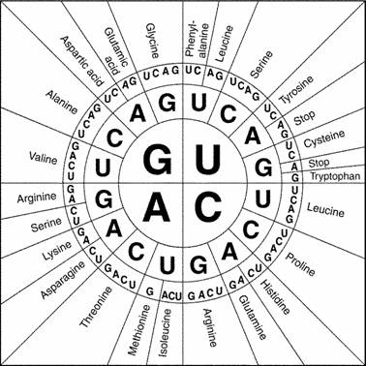

Using the table above, read the codons below. Find the name of the amino acid and write it in the space provided. If the letters code for more than one amino acid, separate the names by dashes

U U A : _________________________________________________________________

G A G : _________________________________________________________________

U A U C U A : __________________________________________________________

A U C U U G : ___________________________________________________________

A A G A G U U C G : _____________________________________________________

A A A U U U G G G : _____________________________________________________

C C A G C U A G A G G G U G G C U G U C A : ______________________________
Molecules of transfer RNA (tRNA) are formed in the nucleus and migrate into the cytoplasm. There are twenty different types of tRNA, one for each kind of amino acid. The tRNA molecule has two ends. One end can carry only one kind of amino acid molecules. The opposite end has a three-base segment called an anticodon, which is complementary to a codon on mRNA.

In protein synthesis, with a ribosome attached to an mRNA, a tRNA molecule carrying its special amino acid molecule briefly attaches to mRNA at its complementary codon. Next a tRNA molecule complementary to the adjacent codon briefly attaches to the mRNA. The ribosome moves along the mRNA to that point of attachement. During each brief attachment among tRNA, mRNA, and ribosome peptide bonds form between the amino acids. As these bonds form, the tRNA molecules are released from their amino acids, and also from the mRNA. Each is free to attach to another molecule of its special amino acid and carry it to another point along the mRNA. The ribosomes move along the mRNA as amino acids are added, one at a time, to a growing chain. This continues until a termination code is encountered.

Determine the anticodon for each codon below. Write it in the space provided

G G U: ________________________________________________________

C G C: ________________________________________________________

A U G: ________________________________________________________

U C G: ________________________________________________________
A A A: ________________________________________________________

C U G: ________________________________________________________

Procedure:

1. Cut out the tRNA models with amino acids attached

2. Cut out the mRNA strands and tape them together so that strand 1 forms the left end fo a long strand, strand 3 forms the right end, and strand 2 is in between

3. Starting at the left of the mRNA strand, find a tRNA molecule with an anticodon complementary to the first codon. With a small piece of tape, attach the tRNA to the mRNA strand, anticodon to codon.

4. For the next codon, find a tRNA with the complementary anticodon. Tape the tRNA in place to the mRNA. Also use a small piece of tape between the two amino acids to represent a peptide bond
5. Once the peptide pond has been formed, the tRNA molecule attached first is released. Carefully cut the tape attaching the first tRNA to the mRNA, and cut the line that separated the tRNA and the amino acid. Save the amino acid chain you have produced.

6. There are three termination codons in the genetic code. When a termination code is read, the strand of amino acids is released, folding and twisting to form the final, complex structures of the protein

7. Repeat steps 4 and 5 along the mRNA strand. When you have used up all the tRNA-amino acid models provided, you will notice that there is one codon left on the mRNA – a termination codon. Cut the tape between the mRNA and the tRNA, and the line between the last tRNA and amino acid, thus releasing the chain of amino acids

Below, write the sequence of amino acids (in abbreviation) that was formed by translation of the mRNA strand

______________________________________________________________________

Analysis:

1. Write the order of nucleotides in mRNA that would be transcribed from the following strand of DNA
G T A T A C C A G T C A T T T G T C

List in order the amino acids coded by this sequence

mRNA: _________________________________________________________________

amino acids: _____________________________________________________________

2. Sometimes a mistake occurs in the translation of an mRNA strand. Suppose that the reading of the mRNA strand in question 1 began by mistake at the second nucleotide instead of the first. The first codon would be AUA.

Write the sequence of amino acids that would be formed:

_______________________________________________________________________

3. Suppose the bases of the DNA strand in question 1 were not transcribed correctly and the mRNA read
C A C A U G G U U A G U A A G C A G

How many mistakes were made in transcription? Write the abbreviations for the amino acids that would be formed by translation of the mRNA

_______________________________________________________________________
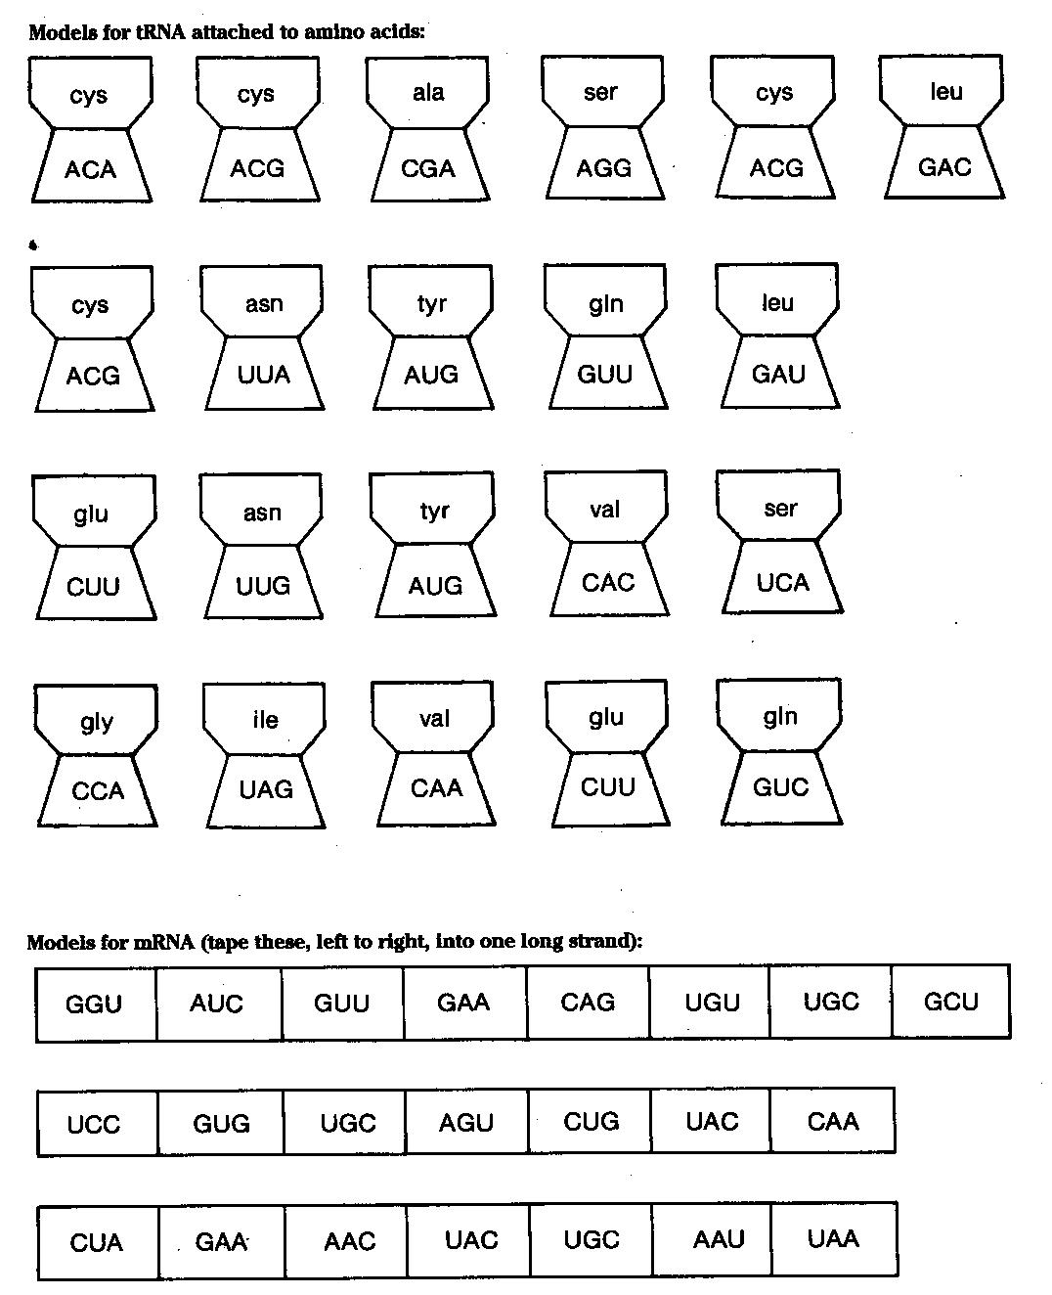

Probability and Inheritance

Gregor Mendel studied inheritance in garden peas, and although he did not understand the mechanisms of inheritance, his work became the basis for the modern study of genetics. From his studies on the inheritance of certain traits in pea plants, Mendel formulated three laws of inheritance; the law of dominance, the law of segregation, and the law of independent assortment.
The value of studying genetics is in understanding how we can predict the likelihood of inheriting particular traits. This can help plant and animal breeders in developing varieties that have more desirable qualities. It can also help people explain and predict patterns of inheritance in family lines.
In this activity, you will learn some principles of probability. You will use the principles and Mendel’s laws to predict the inheritance of traits.

Materials:

2 pennies (or any coins)
masking tape

Procedure:

PART I:

1. Toss a penny 20 times. Have your partner count how many times it lands heads up and how many times it lands tails up
Write the totals under the Observed column for 20 tosses in Table 1

2. The law of probability states that when a procedure can result in two equally likely outcomes, the probability of either outcome is ½ or 50%.
What are other examples of events that have a probability of ½ or 50%?

3. How many times, out of 20 tosses, would you expect heads to appear and how many times would you expect tails to appear? Write you answers in the Expected column for 20 tosses in Table 1.

4. Calculate the deviation by subtracting the expected number from the observed number. Record these in the Deviation column for 20 tosses in Table 1 (make all numbers positive)

5. Repeat the procedure above, but tossing the penny 30 times and then 50 times and counting how many times heads and tails appear.

Table 1
 |  | Heads | Tails
20 Tosses | Observed
20 Tosses | Expected
20 Tosses | Deviation
30 Tosses | Observed
30 Tosses | Expected
30 Tosses | Deviation
50 Tosses | Observed
50 Tosses | Expected
50 Tosses | Deviation
Total | Observed
Total | Expected
Total | Deviation

PART II:

1. Toss two pennies simultaneously 40 times. Keep track of how many times heads/heads, tails/heads, heads/tails, and tails/tails occur. Count tails/heads and heads/tails together
Record the numbers for each combination in the Observed column in Table 2

2. Calculate the percent of the total that each combination (heads-heads, heads-tails, or tails-tails) occurred and record it in the proper column. To find the percent, divide each observed number by 40 and multiply by 100.

According to the law of probability, when there are four equally likely outcomes from a procedure, the probability that one of the outcomes will occur is ¼ or 25%. We can see how this is calculated. For example, we know that in tossing two pennies, the probability of heads occurring on one penny is ½. The probability of heads occurring on the other penny is also ½. The probability of heads occurring on both pennies in one toss is ½ x ½ = ¼.

3. Using the law of probability, predict the expected outcomes of tossing two pennies.
Record the expected numbers in the proper column in Table 2

Calculate the percent of the total that each combination is expected to occur, as you did above. Enter these numbers in the proper column

Calculate the deviation by subtracting the expected from the observed and enter your results in Table 2

Table 2
Combinations | Observed | % | Expected | % | Deviation
Heads Heads
Heads Tails
Tails Heads
Tails Tails
Total | 40 | 100% | 40 | 100%

PART III:

We can use the law of probability to predict the probability of given genetic traits appearing in the offspring of particular parents. Punnett squares can also be used to make these predictions.
When gametes are formed, the pair of genes that determine a particular trait separate, and one gene goes to each gamete. When fertilization occurs, a male and a female gamete fuse. The resulting zygote, which develops into the new individual, now contains two genes for the trait. Which two of the parents’ genes appear in the zygote is a result chance.
In this case we will consider the inheritance in pea plants of round and wrinkled peas. R will represent the dominant gene for round peas and r will represent the recessive gene for wrinkled peas.

1. Put a small piece of masking tape on each side of two pennies. On one penny write “R” on each side. One the other penny write “r” on each side

2. Toss the pennies several times

What combination of genes always appears?

Would the offspring with these genes be round or wrinkled?
3. Replace the old tape with new tape. On each penny, write R on one side and r on the other side. Toss the coins simultaneously until all possible combinations of genes have appeared.

What combinations of genes appear?

For each of the combinations, would the offspring be round or wrinkled?

Analysis:

1. In Part I, what was the expected ratio of heads to tails for tosses of a single coin? Did your results always agree with the expected ratio? If not, what would be a reason for the deviation?

2. Compare the deviations from the expected for 20, 30, and 50 tosses? What seems to be the relationship between the sample size and deviation?

3. In Part II, what was the probability that tails would appear on both coins? How did you arrive at this answer?

4. What was the probability that heads-tails (or tails-heads) would appear? Show your calculations.

5. If you tossed two coins simultaneously 400 times, would you expect the deviation to be greater or les than it was in tossing them 40 times?

6. In Part III, when an RR plant was crossed with an rr plant, would the offspring have round peas or wrinkled peas?

7. Which of Mendel’s laws did you apply to answer question 6?

8. Complete the Punnett square for the cross of RR and rr plants

9. Complete the Punnett square for the cross of Rr and Rr plants

10. Draw a Punnett sqaur to illustrate an Rr x rr cross. Show the genes of the parents, the possible gametes, and the types of offspring.

11. Mendel tested several different traits of peas. One of these traits was for the color of the pod. Green is the dominant trait; yellow is the recessive trait. Use G to represent the gene for green pods and g for yellow pods. Complete Punnett squares to show the expected offspring of a mating of a plant having yellow pods and one having green pods.
(Hint: the green plant may be GG or Gg)

Pedigree Analysis

A diagram showing the transmission of a trait through several generations of a family is called a pedigree. IN figure 1, generation 1 is made up of grandparents, generation II is their children, and generation III is their grandchildren.

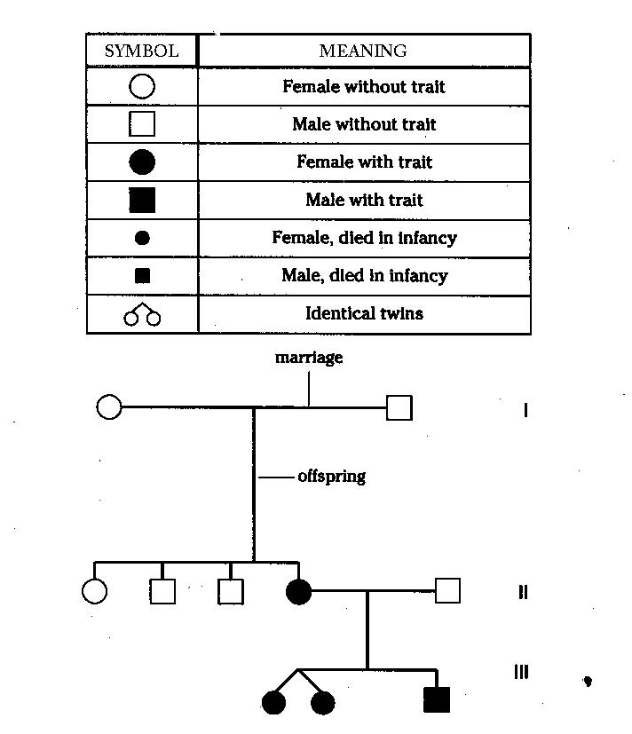

Individuals who lack an enzyme needed to from the skin pigment melanin are called albinos. Normal skin pigmentation is dominant.
Use A to represent the allele for normal skin and aa to represent the genotype for albinism. Where you cannot be sure whether an individual with the dominant trait is heterozygous or homozygous, show the genotype as A __

Individual | Genotype
1
2
I
3 | 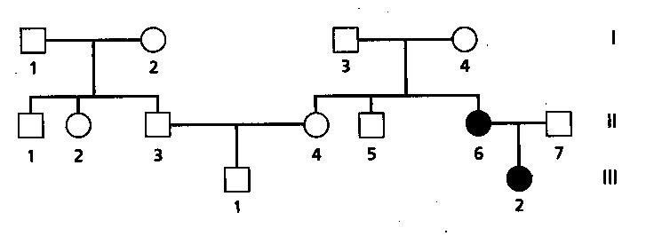
4
1
2
3
II
4
5
6
7
1
III
2

Individual | Genotype
1
2  I | 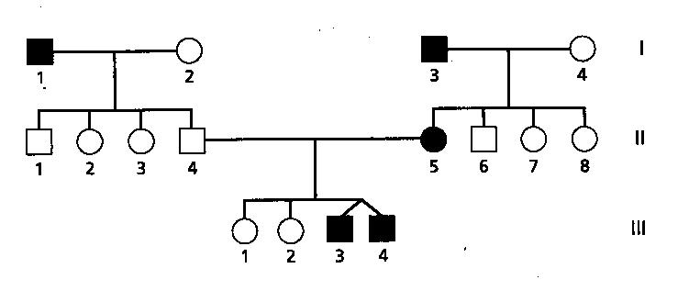
3
4
1
2
3
II
4
5
6
7
1
III
2
Analysis:

1. In the pedigree in Figure 2, if individuals 6 and 7 have another child, what is the chance that it will be an albino?

2. In Figure 2, can you determine the genotypes of individuals 1 and 2 in generation I? Explain.

3. In the pedigree diagram in Figure 3, if individuals 4 and 5 in generation II have another child, what is the probability that it will be a taster?

4. In Figure 3, if individual 8 in generation II married a man with genotype TT, what is the probability that she will have a nontaster child? Illustrate your reasoning with a Punnett Square.

Practice:

Huntington Disease, a condition that leads to progressive degeneration of brain cells, which in turn causes severe muscle spasm, personality disorders, and death in 10 -15 years from onset, is inherited as a dominant trait. Thus, affected individuals only need one copy of the allele to exhibit the condition.
The homozygous recessive individual will not have any chromosomes affected with the trait. Using H to indicate the dominant condition and h to indicate the recessive condition, individuals that are HH or Hh will show high cholesterol and individuals that are hh will be normal.
Determine the genotypes for each individual in the pedigree. You may write the answers below the symbols.
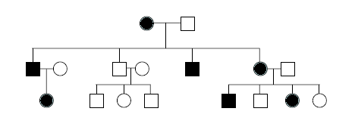
Genetics

Visit the following website and answer the questions that follow
http://www.biology.arizona.edu/mendelian_genetics/mendelian_genetics.html

- For each problem, picking the correct answer will result in a new screen with a short explanation of why that is the correct answer.
- If the wrong answer is picked, the tutorial for that problem automatically comes onto the screen.
- If you do not know how to do the problem, feel free to click on the tutorial button before guessing the wrong answer.
- Doing each and every one of the problems will assist you in answering the following questions.

Click on Monohybrid Cross and Begin the Problem Set

1. Draw the results of a Punnett Square between two Heterozygous Spherical Shaped Pea Seeds

2. What is Mendel’s Law of Segregation?

3. What ratio of dominant to recessive phenotypes will result from a cross between two heterozygous individuals?

4. If you knew the phenotype of an individual to be the dominant trait, why can you not be sure of the individual’s genotype? How can you figure out the genotype of the individual? What would the results reveal?

5. What is incomplete dominance? Give an example of its inheritance pattern.

6. Explain how human blood type is inherited. What are the possible offspring of a woman with type A blood and a man with type B blood. Draw a Punnett Square to show your answer.

Return to the Mendelian Genetics Site, then Click on Monohybrid Cross and Begin the Problem Set

1. What are the possible combinations of alleles in the gametes produced by an individual hybrid for two traits? (Example: TtYy).

2. Draw a Punnett Square to outline the inheritance pattern of two individuals described in the problem above (A Dihybrid Cross)

3. What is the Law of Independent Assortment?

4. Draw a Punnett Square for a SsYy x ssyy test cross.

5. What are linked traits? Why do they change the usual inheritance patterns Mendel uncovered?

6. What is epistasis? Give an example.

Return to the Mendelian Genetics Site, then Click on Sex-Linked Inhertiance and Begin the Problem Set

1. What does it mean if a trait is X-linked?

2. Use a Punnett Square to show the inheritance of a white-eyed female fruit fly and red-eyed male (White eyes are X-linked, recessive)

3. Why are male’s never carriers of x-linked traits?

4. Which of a man's grandparents could not be the source of any of the genes on his Y-chromosome? Which of a women's grandparents could not be the source of any of the genes on either of her X-chromosomes?
Evolution of a Population
Rabbit Activity

Vocabulary:

Allele: __________________________________________________________________
Genotype: ______________________________________________________________
Phenotype: _____________________________________________________________
Homozygous: ___________________________________________________________
Heterozygous: ___________________________________________________________
Dominant: ______________________________________________________________
Recessive: ______________________________________________________________

Natural Selection = differential success in the reproduction of different phenotypes resulting from the interaction of organisms with their environment

Evolution occurs when natural selection causes changes in relative frequencies of alleles in the gene pool

In this activity, you will examine natural selection in a small population of wild rabbits. Evolution, on a genetic level, is a change in the frequency of alleles in a population over a period of time. There are a variety of genetic traits that affect the survival of rabbit in the wild. One such trait is the trait for furless rabbits. The furless rabbit is rarely found in the wild because cold winters are a definite selective force against it.
One color M&M will represent the allele for fur, and a different color M&M will represent the allele for no fur. The container represents the countryside where rabbits will randomly mate.

Directions:

1. Label one dish FF for the homozygous dominant genotype
2. Label a second dish Ff for the heterozygous condition
3. Label a third dish ff for those rabbits with the homozygous recessive genotype
4. Place 50 Black and 50 White M&Ms in a container and mix them.
5. Without looking at the M&Ms, select two at a time, and record the results on the data sheet next to “Generation 1”
a. If you draw one Black M&M and one White M&M, for example, place a mark in the chart under “Number of Ff individuals”
b. Place each pair into the appropriate dish and mark it as one individual

6. Continue drawing pairs of M&Ms and recording the results in your chart until all M&Ms have been selected and sorted.

7. The ff bunnies are born furless. The cold weather kills them before they reach reproductive age, so they can’t pass their genes on to the next generation. Place the M&Ms from the ff container aside (to be eaten at a later time) before beginning the next round.

8. Count the F and f alleles (M&Ms) that were placed in each of the dishes in the first round and record the number in the chart in the columns labeled “Number of F alleles” and “Number of f alleles.” Count each M&M, not each pair.

9. Place all the M&Ms back into the main container and mate them again (Generation 2)

10. Repeat the previous steps up to 10 generations. Make sure everyone in your group has a chance to either select the M&Ms or record the results.

11. Determine the gene frequency of F and f for each generation and record them in the chart in the columns labeled “Gene frequency F” and “Gene frequency f.”
a. To find the gene frequency of F, divide # of F by the total # of alleles
b. Express the results in decimal form.
c. The sum of the frequency of F and f should total 1 for each generation

12. Graph your frequencies.
a. The horizontal axis should be generation and the vertical axis should be the frequency in decimals.
b. Plot all frequencies on one graph.
c. Use one color to connect the data for F and another color for f.

13. Complete the discussion questions with your group while you eat the M&Ms

Discussion Questions:

1. Compare the number of alleles for the dominant characteristic with the number of alleles for the recessive characteristic from the 1st generation to the 10th generation

2. Compare the frequencies of the dominant alleles to the frequencies of the recessive allele from the 1st generation to the 10th generation

3. Was your original hypothesis correct?

4. Suppose that among the rabbits with fur there is another chromosome allele pair that determines black fur versus white fur. What sort of environmental selection pressure may cause a similar change in the frequency of the black alleles compared the white alleles?

DATA SHEET

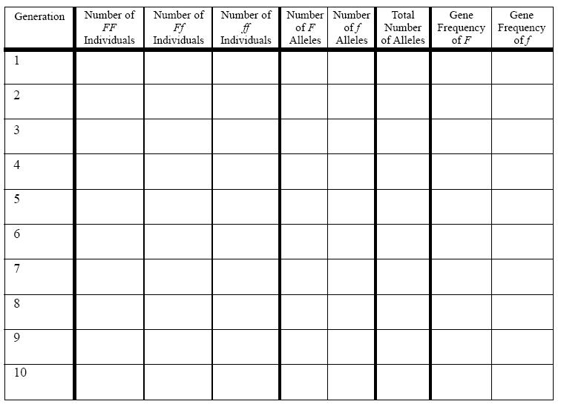

The Nitrogen Cycle Game

Background:
Take a deep breath! What did you just inhale? If you thought “air”, you are right! Air is made of many types of particles. We most often think of air as oxygen (O₂), but the Earth’s “air”, better known as the atmosphere, is 78% nitrogen gas (N₂) and only about 21% oxygen gas. The Earth’s atmosphere is one of the many things that makes out planet so unique. Living organisms depend on the Earth’s atmosphere for survival. In this reading you will learn how plants and animals depend on nitrogen for survival.
In every acre of land (about the size of a football field) there are about 35,.000 tons of nitrogen particles. This is the weight of about 18 elephants. Nitrogen is important for plant and animal growth. It is one of many elements needed to build proteins which form muscles in animals. It is also important in forming enzymes needed for animals to digest food. Nitrogen is one of the elements the unique chemical chlorophyll which allows plants to capture energy from the sun and make food for themselves. Nitrogen is an extremely important chemical and life would not exist if plants and animals if not have it available to them.
Nitrogen exists in many forms. The most abundant form is nitrogen gas (N₂). Plants and animals cannot use nitrogen gas. They must absorb nitrogen as an element in other compounds. Nitrogen can exist in many forms including nitrates (NO₃), nitrites (NO₂), ammonium (NH₄) and ammonia (NH3).

Nitrogen Fixation
The process of changing nitrogen has into nitrogen usable by plants is called nitrogen fixation. Nitrogen gas can be hit by lightning to become nitrates, a compound that plants can use, but most often nitrogen gas is converted to usable nitrogen by nitrogen-fixing bacteria or laboratory chemical processes.
Nitrogen-fixing bacteria naturally exist in soil and water. As part of their life processes, the convert nitrogen gas to nitrates which plants can use. Some nitrogen-fixing bacteria, called Rhizocia, live within the root structures of certain plants called legumes. The special root structures in which they live are called nodules. Farmers often plant legumes such as beans, alfalfa and peas to replenish the usable nitrogen in the soil. The plant remains are turned into the soil leaving nitrogen that can be used by the next crop – usually a crop that cannot fix its own nitrogen.
Nitrogen gas is also converted into commercial inorganic fertilizers in factories. These fertilizers contain nitrogen in a form plants can use.

Nitrification:
Another part of the nitrogen cycle transfers nitrogen from dead plants and animals into the soil. This is called nitrification. As you know, certain bacteria and fungi decompose dead plants and animals. As they do this, they produce ammonia. Special nitrifying bacteria “eat” the ammonia particles and release nitrites. Then, special nitrate bacteria “eat” the nitrites and release nitrates – a nitrogen form that plants and animals can use. As you can see, bacteria are very important tiny organisms that we depend upon for survival.

Denitrification:
Denitrification is the process in which nitrogen is returned to the air as nitrogen gas (N₂). This process is also completed by a group of bacteria – denitrifying bacteria. These bacteria are found in the soil. Volcanic eruptions also rerun nitrogen gas to the air.

Humans and the Nitrogen Cycle:
Human interactions with the environment can influence the nitrogen cycle in many ways. The burning of fossil fuels to produce electricity and operate cars releases nitrogen compounds into the air. Human waste is high in nitrogen and if improperly processed, it affects waterways. Farmers have the challenge of making sure that the appropriate amounts of usable nitrogen are available to crops at the appropriate times. Too little nitrogen will produce unhealthy plants. Heavy watering or heavy rains may result in moving nitrogen below the root zone of plants where it cannot be utilized. This leaching, or the application of too much nitrogen fertilizer, can cause groundwater and stream contamination. Laboratory and field research, in the area of the nitrogen, is an ongoing process. The goal is to ensure that the nitrogen cycle remains in balance so that plants and animal life can continue to exist on Earth.

Around and Around Nitrogen Goes!
(A nitrogen cycle game)
INTRODUCTION:
Plants require many nutrients for growth. As you already know, one of the nutrients plants require is nitrogen. Although the Earth’s atmosphere is over 70% nitrogen gas, plants are unable to use it. Plants can only absorb nitrogen in a few forms, one of which is nitrate.

OBJECT OF THE GAME:
The object of the game is for you to end up with the ideal amount of nitrates in your plot of soil. The person with the ideal number of nitrate particles in his/her plot of soil will have the most abundant crop and will be winter of the game. The ideal number will be revealed at the end of the game.

GAME INSTRUCTIONS (for groups of 3 or 4 people):

1. Pass out one soil plot to each student.

2. Shuffle the task cards and put them where everyone in your group can reach them

3. Put 10 nitrate tokens in each person’s soil plot. The tokens represent nitrates, a source of nitrogen which is usable by plants.

4. Place the remaining tokens in a central location for use by the entire group. This central location will represent the Earth’s atmosphere.

5. In a fair manner, determine which student will go first

6. Have the first player draw a task card and read it to the group. Have the farmer do what the card indicates

→ If the card indicates to add nitrates to the soil, take the appropriate number of
nitrogen particles from the “atmosphere” and placing them in the soil.

→ If the card indicates to change one of the nitrate particles into an unusable
nitrogen particle, remove one nitrate particle from the soil and place it where
the card indicates.

→ If the task asks you to remove more nitrogen from your soil than you have,
remove as many particles as you can and then proceed to the next farmer.

7. Continue this procedure with each player until all of the task cards are gone OR your teacher calls time.

8. At the conclusion of the game, have each student count how many nitrate panicles is in his/her soil. Listen to your instructor to determine who won the game.

A farmer plants a cover crop of beans, Beans are legumes. Legumes fix nitrogen into the soil. Add 2 nitrates to your soil. | A farmer buys manure from his neighbor’s dairy to spread around his grapes. Manure is high in nitrogen which is decomposed into nitrates. Put 1 nitrate in your soil.
There is a big lightning storm in the Midwest corn belt. Lightning converts some nitrogen gas into nitrates. Add 1 nitrate to your soil. | It is late winter and there has been much winter rain. Nitrogen is lost due to leaching. Remove 3 nitrate particles. There are still some fallen leaves left under the trees. Decomposers live in these leaves Add 2 nitrates back into your soil.
A classroom makes a compost pile. After two weeks, the students notice the organic matter decomposing and the soil is very warm. After one month, the class spreads the decayed organic matter into the school garden. Add 1 nitrate to your soil. | The farmer harvests the rice in his field but leaves the stubble from the plants. Many animals and decomposers eat and live in this stubble until it gradually rots away. Add 2 nitrates to your soil.
Early Native American farmers planted beans around their corn plants for natural fertilizing. Beans are in the legume family and can fix nitrogen. Add 1 nitrate to the soil. | Denitrifying bacteria convert nitrogen in animal manure to nitrogen gas. Remove 2 nitrates from your soil.

An golf course owner adds the recommended amount of ammonium sulfate to the golf greens. Add 2 nitrates to your soil. | A septic tank leaks raw sewage (which is high in nitrates) into the water which you use to irrigate your fields. Add 8 nitrates to your soil.
A forest is left undisturbed and the soil contains denitrifying and nitrifying bacteria. Remove 2 nitrates from your soil and then add 2 nitrates back into the soil | You grow corn on your land for 3 seasons straight without adding any type of fertilizer or organic matter. Remove 3 nitrates from your soil.
A farm using sustainable agricultural practices returns as many nutrients to the soil as are removed from the soil by crops. Do not add or remove any nitrate particles. | A peanut farmer inoculates the soil with Rhizobia bacteria. These bacteria can convert nitrogen gas to nitrates. Add 4 nitrates to your soil.
A large marine estuary was contaminated with oil from a leaky oil barge. A lot of the natural bacteria were destroyed. Remove 6 nitrates from your coastal soil. | An “el nino” (a warm water current) increased the water temperature of the Sacramento Delta waterways. Denitrifying bacteria began to rapidly flourish. Remove 2 nitrates from your soil.

A farmer raises and puts millions of earthworms into the soil. Add 1 nitrate to your soil. | A farmer applies an ammonium sulfate fertilizer to his crop in the spring. This fertilizer was made by changing nitrogen gas particles to ammonia which changes into nitrate. Add 2 nitrates to your soil.
The lemon orchard, weighted down with lots of fruit, is ready for harvesting. No sooner does the crop get picked, than the trees are in bloom again to set more fruit. Not a lot of plant material is returned to the ground from which it came. Remove 2 nitrates from your soil and return them to the atmosphere. | A winter freezing slows down natural processes. Nitrogen-fixing bacteria die and the plants cannot absorb the nitrogen they need. Nitrogen gas is put back into the air. Return 2 nitrates to the atmosphere.
There is too much irrigating and nitrogen is leached beyond the root system of the plants. The nitrogen can no longer be used by plants or decomposers. Remove 2 nitrates from your soil. | Fungi attack a corn crop and decompose a crop that was meant for humans. Add 2 nitrates to your soil.
A chemical spill kills all decomposers in a particular area. Denitrifying bacteria are quicker to return than other decomposers. Return 2 nitrates to the atmosphere. | A home gardener adds three times the recommended amount of fertilizer to a garden plot so the garden will grow quicker. The plants die, but the soil has lots of nitrates in it. Add 6 nitrates to your soil.

Predator Prey Simulation Lab

You will be playing a game that simulates the interaction between a wolf population and a rabbit population in a Temperate Grassland Ecosystem. Wolves feed on rabbits and reproduce if they catch three rabbits in one round of this game (one round represents one generation). Rabbits double their population by when all uncaught rabbits reproduce in each round of the game.
Make a hypothesis about what will happen to the rabbit population compared to the wolf population over the course of 10 generations in this ecosystem:

________________________________________________________________________

________________________________________________________________________

________________________________________________________________________

Objective:

To investigate how populations are affected by predator-prey relationships over several generations.

- Large squares represent the wolves
- Small squares represent the rabbits
- The white sheet of paper is the meadow

Procedure:

1. In your group of 4 students decide which 2 students will be in charge of the rabbit population (the rabbit managers) and which two will be in charge of the wolf population (the wolf managers)

2. To start the game, the rabbit managers distribute three rabbits evenly on the meadow.
The rabbit managers will add active rabbits by spreading them out evenly on the meadow each round and removing rabbits when they are caught.

3. The wolf managers throw active wolf cards and add or remove active wolves from the meadow.

4. All animals that are removed from the meadow are placed back in the reserve stacks.

One round (one generation):
- The wolf managers toss each active wolf square into the meadow in an effort to catch rabbits. The toss must leave a wolf manager’s hand outside the meadow area. As long as the wolf square touches a rabbit square, that rabbit is considered to be caught

- Each wolf that can catch three rabbits with one toss has enough energy to reproduce, so the wolf managers double the surviving wolf population in the next round.

- After the caught rabbits are removed, the remaining rabbit population is always doubled for the next round

- If a wolf cannot catch three rabbits in a round, the wolf starves and is removed from the meadow by the wolf managers

- If there are no surviving rabbits, a new round is begun with three new rabbits, which immigrate into the meadow
- If there are no surviving wolves, a new round is begun with a new wolf, which immigrates into the meadow, and double the number of rabbit left at the end of the last round.

To Start:
- Begin the game with one wolf and three rabbis. Record these numbers as rabbit and wolves in the meadow. Continue to record their counts at the beginning of each round for the 10 generations in the game.

- One of the wolf managers should toss a wolf card into the meadow in an attempt to land on at least three rabbits. Probably, the first wolf (or the first few wolfs) will catch fewer than 3 rabbits and starve.
  - The rabbit manager should double the rabbit population and place them in the meadow

- The wolf managers toss a new wolf into the meadow

- If the wolf catches three rabbits, remove three rabbit, add a wolf, and double the remaining rabbits for the next round. If the wolf was unsuccessful, begin the next round with a new immigrant wolf, and continue to double the remaining rabbits.

- Continue additional rounds. Eventually the rabbit population will increase to a level that allows the wolf to catch three rabbits in a single toss. If the wolf catches three rabbits, it not only survives, but also reproduces. It has one baby wolf for each rabbit it catches (if it catches 6 rabbits, it will have two babies)

- Continue to plat the game for 25 generations, recording data at the beginning of each generation.
Results:
- Graph your data using the number of individuals as the dependant variable and the number of generations as the independent variable.

- Use a separate line (different color) on the same graph to represent rabbits and wolves

Questions:

- How do the wolf and rabbit populations affect to each other?

- Under what modifications can both populations continue to grow and exist indefinitely?

- What do you think would happen if you introduced an additional predator, such as a coyote, which would allow fewer rabbits to reproduce?

- What would happen if you introduced another type of rabbit, one that could run faster and escape its predators?

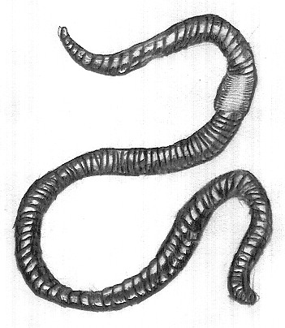
Earthworm Dissection
The earthworm is the best-known member of the
phylum Annelida, the segmented worms. Annelids are
bilaterally symmetrical, and their bodies are divided into
segments both externally and internally. They have a
tube-within0a0tube body structure. The outer tube is the
body wall, while the inner tube is the digestive tract. The
cavity between the outer and inner tubes is the coelom.
In this lab, you will dissect an earthworm in order to observe
the external and internal structures of earthworm anatomy.

Materials:

safety goggles scalpel
dissecting pins gloves
forceps scissors
scalpel dissecting probe
preserved earthworm hand lens
dissection tray

Procedure:

External Anatomy
1. Put on safety goggles and gloves

2. Place earthworm in the dissecting tray and rinse off the excess preservative.

3. Identify the dorsal side, which is the worm’s rounded top, and the ventral side, which is its flattened bottom. Turn the worm ventral side up, as shown in the diagram below.

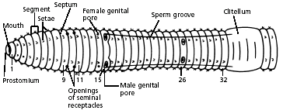

4. Use a hand lens as you observe all parts of the worm, externally and internally.
Locate the conspicuous clitellum, a saddle-like swelling on the dorsal surface.
The clitellum produces a mucus sheath used to surround the worms during mating and is responsible for making the cocoon within which fertilized eggs are deposited.

The anterior of the animal is more cylindrical than the flattened posterior and is the closest to the clitellum. The ventral surface of the earthworm is usually a lighter colour than the dorsal surface.

The mouth is located on the ventral surface of the first segment while the anus is found at the end of the last segment.

Find the anterior end by locating the prostomium (lip), which is a fleshy lobe that extends over the mouth. The other end of the worm’s body is the posterior end, where the anus is located.
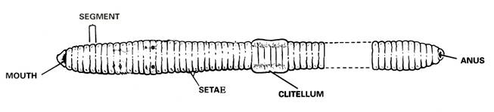

5. Locate the clitellum, which extends from segment 33 to segment 37.
Look for the worm’s setae, which are the minute bristle-like spines located on every segment except the first and last one.

Run your fingers over the ventral surface of the earthworm’s body. You should be able to feel bristle-like setae used for locomotion

6. Refer again to the diagram of the ventral view of the worm to locate and identify the external parts of its reproductive system.

Find the pair of sperm grooves that extend from the clitellum to about segment 15, where one pair of male genital pores is located. Look also for one pair of female genital pores on segment 14.

There is another pair of male genital pores on about segment 26. Try to find the two pairs of openings of the seminal receptacles on segment 10. Note: These openings are not easy to see.

Internal Anatomy

1. Position your preserved earthworm dorsal side up and pin it down through the first segment and then again further back behind the clitellum.

2. Cut a slit in the dorsal surface near the posterior pin. Using fine scissors extend the cut forward to the first segment. Be careful not to cut too deep.

3. Starting at the first segment, cut the septa (thin membranes) that internally divide the segments, so the skin can be laid flat.

4. Use additional pins to hold the integument open and expose the organs. Continue to lay the skin back until you have uncovered a centimeter or so of the intestine.

5. Turn the worm dorsal side up. Using a scalpel and scissors, make a shallow incision in the dorsal side of the clitellum at segment 33.

6. Using the forceps and scalpel, spread the incision open, little by little.

7. Separate each septum from the central tube using a dissecting needle, and pin down each loosened bit of skin. Continue the incision forward to segment 1.

8. . Use the diagram below to locate and identify the five pairs of aortic arches, or hearts. Then find the dorsal blood vessel. Look for smaller blood vessels that branch from the dorsal blood vessel.

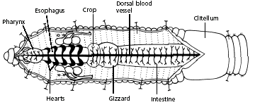

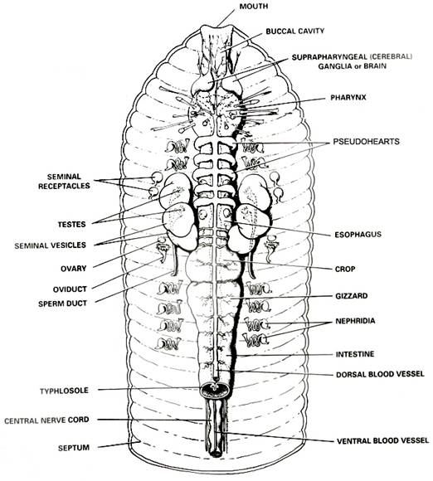
Digestive System

The earthworm is an example of a foraging herbivorous annelid, obtaining food by eating its way through the soil and extracting nutrients from the soil as it passes through the digestive tract.

Starting at the anterior end, locate the muscular pharynx (food ingestion).
This is followed by a tube-like esophagus which terminates in a crop (the wider organ) which serves as a storage stomach.

Posterior to the crop you will find the gizzard.
Gently press on the crop and gizzard to test their firmness. While the crop is soft and thin, the gizzard is muscular (soil is ground up and churned within the gizzard).

The gizzard is followed by a long intestine in which both digestion and absorption occur. Undigested material is voided through the anus.
Locate the digestive tract, which lies below the dorsal blood vessel. Refer to the diagram above to locate the pharynx, esophagus, crop, gizzard, and intestine.

To find organs of the nervous system, push aside the digestive and circulatory system organs. Use the diagram below to locate the ventral nerve cord.

Trace the nerve cord forward to the nerve collar, which circles the pharynx.
Find one pair of ganglia under the pharynx and another pair of ganglia above the pharynx. The ganglia above the pharynx serve as the brain of the earthworm.

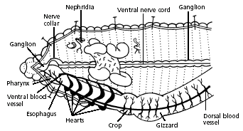

The worm’s excretory organs are tiny nephridia. There are two in every segment. Use the preceding diagram to locate some nephridia.

Use the diagram below to locate and identify a pair of ovaries in segment 13. Look for two pairs of tiny testes in segments 10 and 11. To find these organs, you will again have to push aside some parts already dissected.

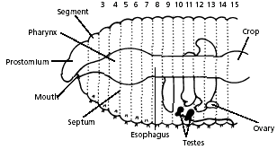

Dispose of your materials according to the directions from your teacher.
Clean up your work area and wash your hands before leaving the lab.

Frog Dissection
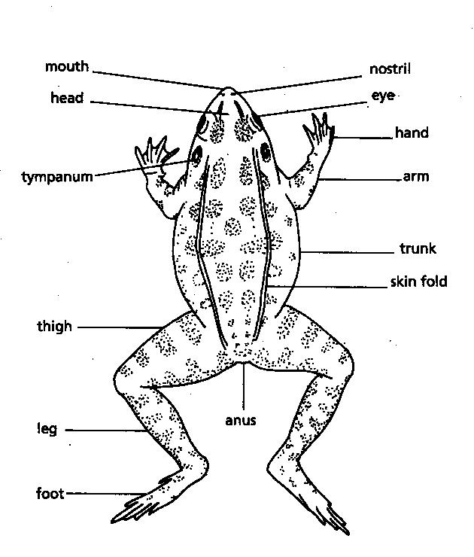
Background:

As members of the class Amphibia, frogs may live some of their adult lives on land, but they must return to water to reproduce. Eggs are laid and fertilized in water. On the outside of the frog’s head are two external nares, or nostrils; two tympani, or eardrums; and two eyes, each of which has three lids. The third lid, called the nictitating membrane, is transparent. Inside the mouth are two internal nares, or openings into the nostrils; two vomerine teeth in the middle of the roof of the mouth; and two maxillary teeth at the sides of the mouth. Also inside the mouth behind the tongue is the pharynx, or throat.
In the pharynx, there are several openings: one into the esophagus, the tube into which food is swallowed; one into the glottis, through which air enters the larynx, or voice box; and two into the Eustachian tubes, which connect the pharynx to the ear. The digestive system consists of the organs of the digestive tract, or food tube, and the digestive glands. From the esophagus, swallowed food moves into the stomach and then into the small intestine. Bile is a digestive juice made by the liver and stored in the gallbladder. Bile flows into a tube called the common bile duct, into which pancreatic juice, a digestive juice from the pancreas, also flows. The contents of the common bile duct flow into the small intestine, where most of the digestion and absorption of food into the bloodstream takes place.
Indigestible materials pass through the large intestine and then into the cloaca, the common exit chamber of the digestive, excretory, and reproductive systems. The respiratory system consists of the nostrils and the larynx, which opens into two lungs, hollow sacs with thin walls. The walls of the lungs are filled with capillaries, which are microscopic blood vessels through which materials pass into and out of the blood. The circulatory system consists of the heart, blood vessels, and blood. The heart has two receiving chambers, or atria, and one sending chamber, or ventricle. Blood is carried to the heart in vessels called veins. Veins from different parts of the body enter the right and left atria. Blood from both atria goes into the ventricle and then is pumped into the arteries, which are blood vessels that carry blood away from the heart.
The urinary system consists of the frog’s kidneys, ureters, bladder, and cloaca. The kidneys are organs that excrete urine. Connected to each kidney is a ureter, a tube through which urine passes into the urinary bladder, a sac that stores urine until it passes out of the body through the cloaca. The organs of the male reproductive system are the testes, sperm ducts, and cloaca. Those of the female system are the ovaries, oviducts, uteri, and cloaca. The testes produce sperm, or male sex cells, which move through sperm ducts, tubes that carry sperm into the cloaca, from which the sperm move outside the body. The ovaries produce eggs, or female sex cells, which move through oviducts into the uteri, then through the cloaca outside the body.
The central nervous system of the frog consists of the brain, which is enclosed in the skull, and the spinal cord, which is enclosed in the backbone. Nerves branch out from the spinal cord. The frog’s skeletal and muscular systems consist of its framework of bones and joints, to which nearly all the voluntary muscles of the body are attached.

Objectives:
• Describe the appearance of various organs found in the frog.
• Name the organs that make up various systems of the frog.

Materials:

safety goggles, gloves, and a lab apron
forceps
preserved frog
dissecting pins (6–10)
dissecting tray and paper towels
plastic storage bag and twist tie
scissors
marking pen
dissecting needle

Procedure:

Put on safety goggles, gloves, and a lab apron.

Place a frog on a dissection tray. To determine the frog’s sex, look at the hand digits, or fingers, on its forelegs. A male frog usually has thick pads on its "thumbs," which is one external difference between the sexes, as shown in the diagram below.
Male frogs are also usually smaller than female frogs. Observe several frogs to see the difference between males and females.
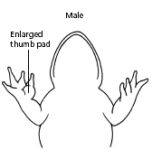 | 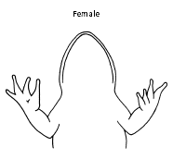

Use the diagram below to locate and identify the external features of the head. Find the mouth, external nares, tympani, eyes, and nictitating membranes.

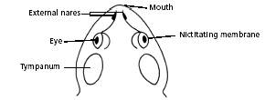

Turn the frog on its back and pin down the legs. Cut the hinges of the mouth and open it wide. Use the diagram below to locate and identify the structures inside the mouth. Use a probe to help find each part: the vomerine teeth, the maxillary teeth, the internal nares, the tongue, the openings to the Eustachian tubes, the esophagus, the pharynx, and the slit-like glottis.
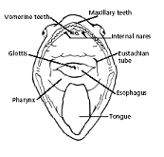
Look for the opening to the frog’s cloaca, located between the hind legs. Use forceps to lift the skin and use scissors to cut along the center of the body from the cloaca to the lip. Turn back the skin, cut toward the side at each leg, and pin the skin flat. The diagram above shows how to make these cuts

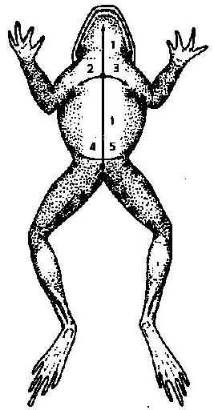
Following the cutting pattern of the image to the right, lift and cut through the muscles and breast bone to open up the body cavity.

If your frog is a female, the abdominal cavity may be filled with dark-colored eggs. If so, remove the eggs on one side so you can see the organs underlying them.

Use the diagram below to locate and identify the organs of the digestive system: esophagus, stomach, small intestine, large intestine, cloaca, liver, gallbladder, and pancreas.
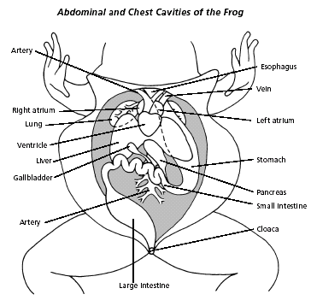

Use a probe and scissors to lift and remove the intestines and liver. Use the diagram on the next page to identify the parts of the urinary and reproductive systems. Remove the peritoneal membrane, which is connective tissue that lies on top of the red kidneys. Observe the yellow fat bodies that are attached to the kidneys. Find the ureters; the urinary bladder; the testes and sperm ducts in the male; and the ovaries, oviducts, and uteri in the female.

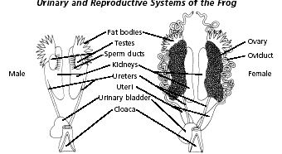

Remove the kidneys and look for threadlike spinal nerves that extend from the spinal cord. Dissect a thigh, and trace one nerve into a leg muscle. Note the size and texture of the leg muscles.

Dispose of your materials according to the directions from your teacher.

Clean up your work area and wash your hands before leaving the lab.

Frog Anatomy:

- Fat Bodies --Spaghetti shaped structures that have a bright orange or yellow color, if you have a particularly fat frog, these fat bodies may need to be removed to see the other structures. Usually they are located just on the inside of the abdominal wall.

- Peritoneum A spider web like membrane that covers many of the organs, you may have to carefully pick it off to get a clear view

- Liver--The largest structure of the the body cavity. This brown colored organ is composed of three parts, or lobes. The right lobe, the left anterior lobe, and the left posterior lobe

- Heart - at the top of the liver, the heart is a triangular structure. The left and right atrium can be found at the top of the heart. A single ventricle located at the bottom of the heart. The large vessel extending out from the heart is the conus arteriosis.

- Lungs - Locate the lungs by looking underneath and behind the heart and liver. They are two spongy organs.

- Gall bladder--Lift the lobes of the liver, there will be a small green sac under the liver. This is the gall bladder, which stores bile. (hint: it kind of looks like a booger)

- Stomach--Curving from underneath the liver is the stomach. The stomach is the first major site of chemical digestion. Frogs swallow their meals whole. Follow the stomach to where it turns into the small intestine. The pyloric sphincter valve regulates the exit of digested food from the stomach to the small intestine.

- Small Intestine--Leading from the stomach. The first straight portion of the small intestine is called the duodenum, the curled portion is the ileum. The ileum is held together by a membrane called the mesentery. Note the blood vessels running through the mesentery, they will carry absorbed nutrients away from the intestine. Absorption of digested nutrients occurs in the small intestine.

- Large Intestine--As you follow the small intestine down, it will widen into the large intestine. The large intestine is also known as the cloaca in the frog. The cloaca is the last stop before wastes, sperm, or urine exit the frog's body. (The word "cloaca" means sewer)

- Spleen--Return to the folds of the mesentery, this dark red spherical object serves as a holding area for blood

- Esophagus--Return to the stomach and follow it upward, where it gets smaller is the beginning of the esophagus. The esophagus is the tube that leads from the frogs mouth to the stomach. Open the frogs mouth and find the esophagus, poke your probe into it and see where it leads.
Fetal Pig Dissection

Mammals are vertebrates having hair on their body and mammary glands to nourish their young. The majority are placental mammals in which the developing young, or fetus, grows inside the female's uterus while attached to a membrane called the placenta. The placenta is the source of food and oxygen for the fetus, and it also serves to get rid of fetal wastes. The dissection of the fetal pig in the laboratory is important because pigs and humans have the same level of metabolism and have similar organs and systems.
To see the organs and organ systems discussed in this lab, you will have to do a very careful dissection. It is very easy to crush or remove important structures before you recognize what they are. You should study accompanying diagrams and compare the structures you see with the diagrams. Except where you are instructed to use your scalpel or scissors, use forceps, probes, and dissecting needles to expose internal structures. Fatty and connective tissues should be removed carefully with forceps.

Objectives:
- Identify important external structures of the fetal pig.
- Identify major structures associated with a fetal pig's digestive, respiratory, circulatory, urogenital, & nervous systems.
- Compare the functions of certain organs in a fetal mammal with those of an adult mammal.
Materials:

Preserved fetal pig
Dissection scissors
Dissecting needles
Dissecting pins
String
Ruler
Dissecting tray
Scalpel
Forceps
Gloves

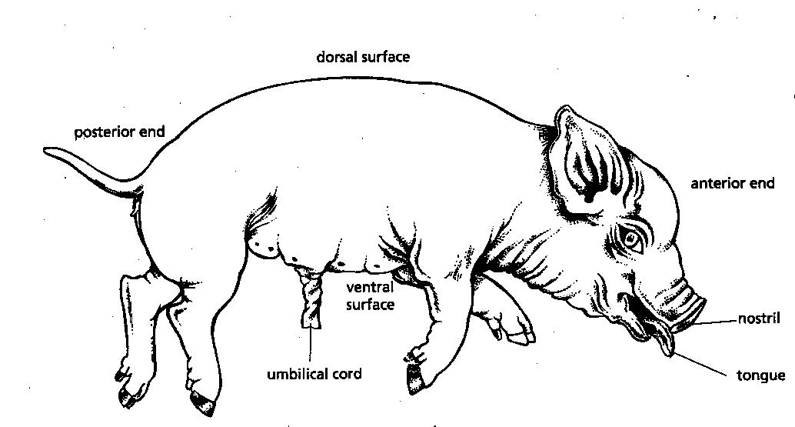

Pick up your pig and examine it. You can estimate the age of the pig from its length. Measure your pig from the tip of its snout to the base of its tail. Using the measurement s given below, estimate the age of your pig

7 weeks: 28mm 15 weeks: 220mm
8 weeks: 40mm 17 weeks: 300 mm

What is the approximate age of your pig? ___________

The sex of a pig can be determined from the external structures. Both males and females have nipples on the ventral side, so the presence of nipples cannot be used to determine sex. In both males and females the anus is located just beneath the tails. In males, the scrotal sac, which contains the testes, is located beneath the anus. The urogenital opening of the male is just posterior to the umbilical cord on the ventral surface. In females, the urogenital opening is beneath the anus, in a spikelike genital papilla.

What is the sex of your pig? ____________

The umbilical cord contains blood vessels that connect the fetus to the placenta. In the pig, the umbilical cord extends from the midline of the ventral surface.
Examine the cut end of the umbilical cord. You should be able to see two arteries and a vein.

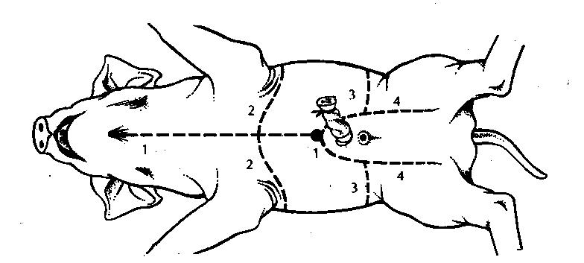

Use the string or cord provided to secure the arms and legs of the pig. Following the diagram above, make incisions with the tip of your scalpel and do not press down too hard. Be particularly careful in the incision over the chest area.

The ends of the diaphragm, the muscle the separates the abdominal and chest cavities, are attached to the body wall.

Gently pull apart the flaps of the body wall along the long incision between the front and hind legs. Do not lift the flap with the umbilical cord. As you separate the flaps under the front legs, use your scissors or scalpel to carefully cur the ends of the diaphragm at the body wall so that the flap can be pinned down.

Carefully pull up the flap with the umbilical cord a slight way. You will see the umbilical vein extending from the inside of the umbilical cord up through the liver toward the head. In order to pull up this flap use your scissors to cut the umbilical vein. Do not cut off the flap. After cutting the vein, just leave the flap extending backward between the hindlegs of the pig

Digestive System

The organs of the abdominal cavity are covered by a membrane called the peritoneum. When you pulled apart the flaps of the body wall to expose the abdominal cavity, some of the peritoneum may have been pulled off. If not, carefully slit the peritoneum and then use your forceps to pull it off the organs of the abdomen

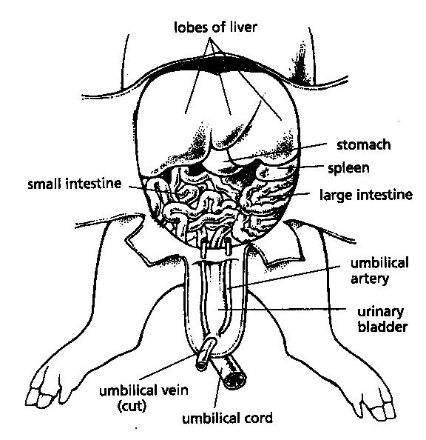

Examine the liver, both the upper and lower surfaces. Locate the gallbladder on the undersurface. Very carefully use your forceps to remove the peritoneum covering the gallbladder. Trace the duct that carries bile away from the gallbladder. Follow it until it enters the digestive tract.

How many lobes does the liver have? _____________

Describe the location and appearance of the gallbladder.

When you have finished examining the liver, remove it. Identify the stomach. The long flattened, reddish organ that lies along the outer curve of the stomach is the spleen.

Find the junction of the stomach and the esophagus. Find where the stomach joins the small intestine. Cut open the upper surface of the stomach, beginning where it joins the esophagus and extending to the junction of the small intestine. Rinse out the stomach under running water and examine its inner surface, particularly where it joins the esophagus and small intestine.

Lift up the stomach and locate the pancreas. It is a whitish organ with granular surface. The pancreatic duct extends from the end of the pancreas nearest the small intestine into the small intestine. However, it is very small and difficult to find.

Examine the small intestine, beginning at its junction with the stomach. Spread apart some of the coils of the intestine and note the mesentery, a membrane that holds the intestine in place. Blood vessels and nerves also run through the mesentery. Find the junction of the small and large intestine.

Cut out a short section of the small intestine. Use a sharp scalpel to cut a very thin cross section of the small intestine and make a wet mount.
Look at the slide under low power. Draw what you see.

Urinary System

Once you have finished your study of the digestive system, remove the stomach and small intestines. Lift the stomach and, using scissors, cut it where it joins the esophagus. Pull up the intestines and cut the large intestine, leaving a short section showing. Cut any attached blood vessels close to eh intestinal wall. Be careful not to destroy the large blood vessels that lie beneath these organs.

The large artery and vein that run along the midline of the dorsal surface of the abdomen are the aorta and the inferior vena cava. Branches from these vessels, the renal arteries and veins, serve the kidneys.
Identify the abdominal aorta and the inferior vena cava

Locate the kidneys, which are large, bean-shaped organs found against the dorsal body wall on either side of the abdomen. The kidneys are outside the peritoneum, so they will probably be covered by that membrane.
Using the forceps, gently pull the peritoneum away from one kidney. Be particularly careful if your pig is female because the small ovary is just below the kidney.
On the side where the kidney is exposed, identify the renal artery and vein and the ureter, a large white tube that carries urine to the bladder.
Trace the ureter from the kidney to the bladder, which is found in the flap of tissue containing the umbilical cord. Identify the urethera, which carries urine from the bladder to the outside of the body.

Use a sharp scalpel to cut through the kidney lengthwise midway between the front and the back. Remove the front half of the kidney.
Draw the cut section of the kidney. Show only the details that you can actually see. If you can see the 3 layers of the kidney, the cortex, medulla, and pelvis, draw and label them.

Reproductive System

Before starting your study of the reproductive system, you will have to open the pelvic region of the pig. Use your scalpel to make an incision, slightly to one side of the midline, through the flap containing the umbilical cord, toward the anus. Pull back the skin, the carefully cut through the muscle and cartilage of the pelvis.

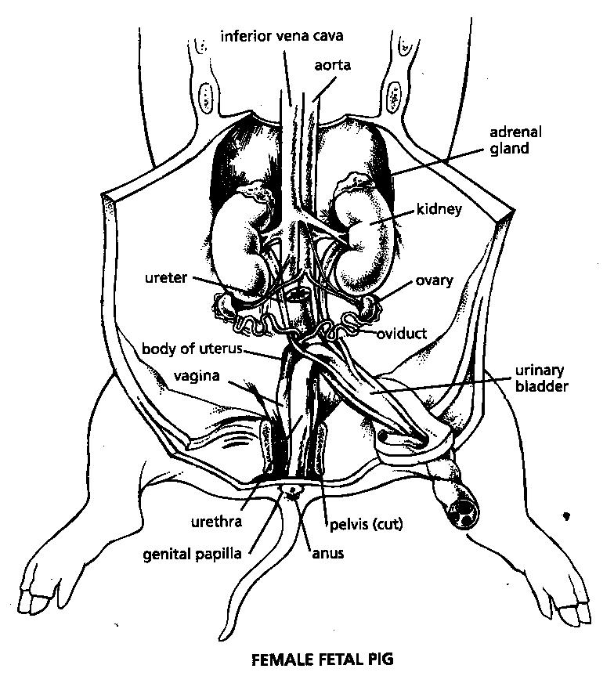

The ovaries are located inside the peritoneum. They are held in place by mensenteries. Eggs released from the ovaries enter the oviducts, which are twiting tubes that carry the egg to the uterus. The uterus, which is small in the fetal pig, is found along the midline of the body. Extending from the uterus is the vagina. The vagina and the urethra share a single opening to the outside of the body anterior to the anus.

Locate an ovary. If you cannot find it on the side where you have dissected the kidney, look on the other side. Remove any fat tissue that may be in the way, but be careful not to damage the oviduct and supporting membrane. From the ovary, follow the oviduct to the body of the uterus. Then trace the vagina toward the urigentical opening, and finally to the genital papilla on the body surface.
In the fully developed male pig, the testes are located in the scrotum, a pound found outside the body wall anterior to the anus. The testes grow originally within the abdomen and descend into the scrotum as the fetus develops. The openings in the abdominal wall through which the testes pass are the inguinal canals. Sperm produced in the testes are stored in the epididymis, a small, coiled tube that lies next to each testis. The epididymis is continuous with the sperm duct. The sperm duct from each testis passes upward through an inguinal canal and enter the urethra. The urethra passes through the penis to the outside of the body.

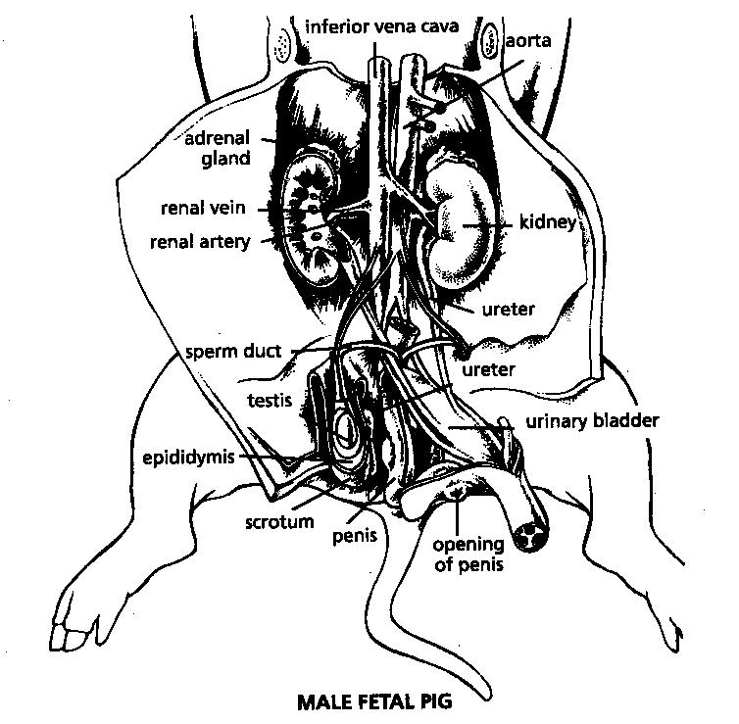

Carefully cut open one of the scrotal sacs and find one of the testes. Identify the epididymis, which begins at the top, or head end of the testis. Follow the epidiymis around the testis, where is joins the sperm duct. Follow the sperm duct upward to where it enters the urethra

Locate the penis, which is found in the strip of the body wall that contains the urinary bladder. Both urine from the kidneys and spem from the testes are released from the body through the penis.

Chest Cavity – Heart and Lungs

The chest cavity, which contains the heart and the lungs, is lined by membranes. The chest wall and the surface of the lungs are covered by the pleural membranes, while the heart is covered by the pericardium.

Gently pull apart the body wall of the chest along the incision made previously. Pin down the two flaps. Carefully remove any of the pleural membrane that is not been pulled away with the body wall. Note how the diaphragm forms a muscular floor for the chest cavity.
Examine the lungs. How many lobes does the right lung have? ____________

How many lobes does the left lung have? _____________
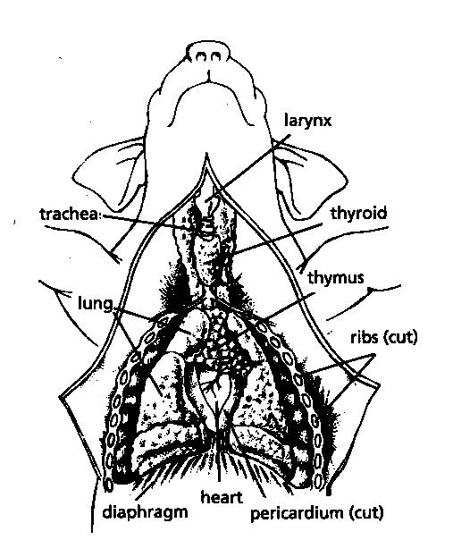

Lift the lungs out of the way and examine the heart, which is enclosed by the pericardium. The upper, or head end, of the heart is partly covered by the thymus gland. Remove the thymus and then cut away the pericardium around the heart.
Remove the thymus and then cut away the pericardium around the heart.
Lift up the bottom of the heart and identify the inferior and superior vena cavae, which enter the right atrium. Identify the pulmonary artery leaving the right ventricle. This large artery divides to form the two pulmonary arteries to the lungs a short distance after leaving the heart.
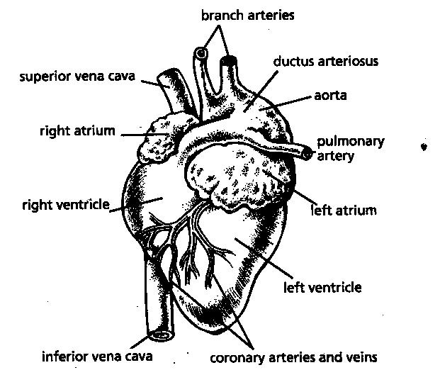

In pigs and in humans there is a vessel called the ductus arteriosus that serves as a shunt between the pulmonary artery and the aorta prior to birth. In the fetus, where the lungs are not functioning in respiration, much of the blood bypasses the lungs. It passes from the right ventricle into the pulmonary artery and then through the ductus arteriosus to the aorta. At birth, the ductus arteriousus closes up.
Using scissors, cut the blood vessels around the heart at a short distance away from the heart. Examine the back, or dorsal, side of the heart. Identify the ductus arteriosus.

With a sharp scalpel, cut through the heart lengthwaise (parallel to the fron and back of the heart). Describe as much of the internal structure of the heart as you can se from your dissection.

With the heart removed, identify the trachea by its cartilage-ring structure. Find where it divides into the two bronchi, which enter the lungs

Identify the esophagus, which lies under (dorsal) to the trachea.

The Head and Nervous System

Examine the head of the big. Open the mouth and examine the tongue, any teeth that are visible, and the back of the throat. To view the epiglottis, glottis, and opening to the esophagus, use your scalpel to slit the corners of the mouth on both sides.

The pig has four pairs of salivary glands whose secretions are carried into the mouth by the ducts. The largest of these is the parotid gland, which extends from the base of the ear to the shoulder and the jaw.
Using your scalpel, make an incision though the skin and facial muscle beginning at the base of the ear. Be careful not to cut into the parotid gland, which lies beneath the muscle layer. Remove the skin and muscle layer and examine the parotid gland. Trace the duct from the gland as far as you can. Beneath the parotid gland is another salivary gland, the mandibular gland. Lift the parotid gland to see the mandibular gland
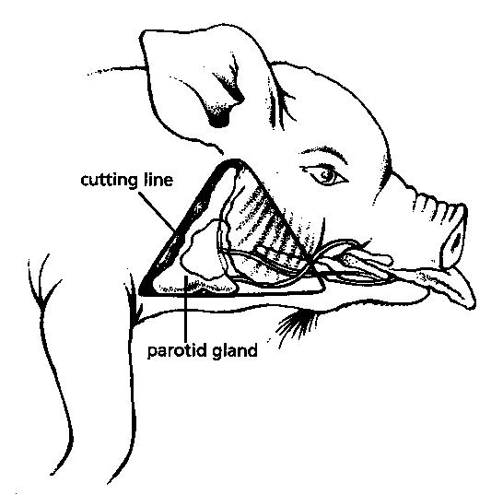

The nervous system of the pig is very similar to that of humans. There is a central nervous system consisting of the brain and spinal cord, and the peripheral nervous system consisting of cranial and spinal nerves.
Using your scalpel, make incisions through the skin of the head as shown below
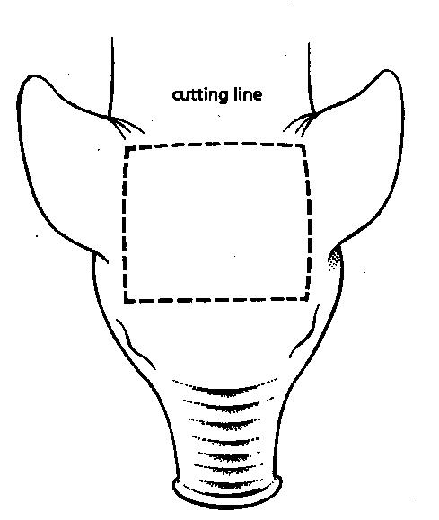

Look for lines in the skull, which indicate where the bones meet. Carefully insert the pointed end of your scissors between the bones. Use the tip of your forceps to pull or break off pieces of the skull until you have opened up most of the skinned area.

The brain and spinal cord are protected by three membranes known as the meninges. The outermost of these membranes, which is just beneath the skull, is called the dura mater. It is the thickest and toughest of the membranes. The surface of the brain is covered by a thin membrane called the pia mater. The third membrane, called the arachnoid membrane, is found between the dura mater and the pia mater. In living animals cerebrospinal fluid fills the space between the two inner membranes.

Cut through the dura mater, exposing the brain. Identify the right and left cerebral hemispheres. Notice the deep longitudinal fissure between them. Identify the cerebellum, which is behind and beneath the cerebrum. Try to identify the medulla, which is behind and beneath the cerebellum. You may remove parts the brain as you have identified them.

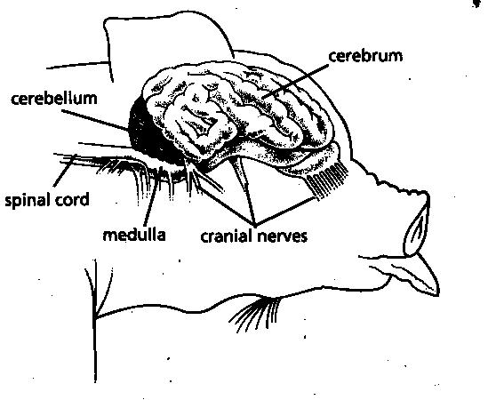
The pig has 12 pairs of cranial nerves. These nerves mainly serve the sense organs of the head. Try to identify one or more of the cranial nerves.

The spinal cord is surrounded and protected by the vertebrae of the spinal column. In the fetal pig, the bones of the spinal column are not completely ossified, so they should not be difficult to cut.

Remove the skin from an area of the back so that about 8-9 centimeters of the spinal column are exposed. Use your forceps and carefully remove remaining tissue so that the spiny extensions of the vertebrae are completely exposed. You may notice thin white nerves that enter the back muscles.
Cut off the tops of the spiny extensions of the vertebrae with your scissors. This will expose the spinal cord and spinal nerves. The enlargements of the spinal nerves where they pass out of the vertebrae are the dorsal root ganglia.

Analysis:

1. What is the function of the umbilical cord in the fetal pig?

2. What two body cavities are separated by the diaphragm?

3. What is the name of the membrane that covers the organs of the abdomen?

4. What small greenish sack is found on the underside of the liver?

5. Would you expect to find food in the stomach of your fetal pig? Explain.

6. What is the function of the ductus arteriosus in unborn mammals?

7. Explain how the structure and function of the trachea differ from that of the esophagus.

8. What was the most interesting part of the dissection for you personally? Why?

Works Cited

Bechely, Lois Andre, and Karen Traiger. "Starting All Over Again." Sept.-Oct. 1994. California Foundation for Agriculture in The Classroom. 10 Aug. 2007 <http://cfaitc.org/LessonPlans/pdf/402a.pdf>.

"BIOLOGY DEPARTMENT LABORATORY SAFETY PROCEDURES." Camden County College. 10 Aug. 2007 <http://www.camdencc.edu/departments/biology/safetyHisto.htm>.

Bjork, Warren B., Ruth D. Horn, William D. Schraer, and Herbert J. Stoltze. The Study of Life: Laboratory Manual. 7th ed. New Jersey: Prentice Hall, 1999.

"DNA Extraction." Univeristy of Maryland Biotechnology Institute. 10 Aug. 2007 <http://www.umbi.umd.edu/~scitech/pdf/DNA.pdf>.

Fisher, Kathleen M. "Building Molecules From Atoms." Bio Manual 1: Molecules and Cells. San Diego State University. 10 Aug. 2007 <http://www.biologylessons.sdsu.edu/ta/classes/lab3/TG.html>.

Jeff, Carmichael, Mark Grabe, and Jonathan Wenger. "Laboratry 7: Respiration." Biology 105 Laboratory Review. University of North Dakota. 10 Aug. 2007 <http://www.und.nodak.edu/dept/jcarmich/101lab/lab7/lab7.html>.

Lapiana, Joseph. "How Does Evolution Work." PBS. 1994. 10 Aug. 2007 <http://www.pbs.org/wgbh/evolution/educators/lessons/lesson4/act1.html>.

Massengale, C. "Earthroom Dissection." Animal Dissections. 10 Aug. 2007 <http://sps.k12.ar.us/massengale/earthworm_dissection.htm>.

Massengale, C. "Frog Dissection." Animal Dissections. 10 Aug. 2007 <http://sps.k12.ar.us/massengale/frog_dissection.htm>.

Massengale, C. "Learning to Use the Microscope." 10 Aug. 2007 <http://sps.k12.ar.us/massengale/microscope_lab.htm>.

"Mendelian Genetics." The Biology Project. 21 Nov.-Dec. 2002. University of Arizona. 10 Aug. 2007 <http://www.biology.arizona.edu/mendelian_genetics/mendelian_genetics.html>.

"Mitosis." Labs Online. 1998. Troy High School. 10 Aug. 2007 <http://www.troy.k12.ny.us/thsbiology/labs_online/home_labs/mitosis_lab_home.html>.

Morgan, William. "Modeling Meiosis." 5 Sept.-Oct. 1997. College of Wooster. 10 Aug. 2007 <http://www.wooster.edu/biology/wmorgan/bio306/Modeling_Meiosis.html>.

Sheard, Neil, Sarah Donnelly, and Colleen Rapaich. "LAB ACTIVITY:Predator-Prey Simulation: Population Growth." Queens University. 10 Aug. 2007 <http://educ.queensu.ca/~science/main/concept/biol/b11/B11LACG2.htm>.

Slish, Donald. "Agarose Gel Electrophoresis." SUNY Plattsburgh. 10 Aug. 2007 <http://faculty.plattsburgh.edu/donald.slish/Electrophoresis.html>.

Stanback, Mark. "Fetal Pig Anatomy." Biology 112. 1 Jan.-Feb. 2005. Davidson College. 10 Aug. 2007 <http://www.bio.davidson.edu/Courses/bio112/Bio112LabMan/cppig.html>.

"Taxanomic Classification and Phylogenetic Trees." McGraw-Hill. 2001. 10 Aug. 2007 <http://www.mhhe.com/biosci/pae/zoology/cladogram/>.

Tice, Shannon. "Photosynthesis Lab." 10 Aug. 2007 <http://chem.lapeer.org/Bio1Docs/PhotoLab.html>.

